

**BREATHE THE FUTURE-HYBRID EDUCATION IN VET**

**Project No: 2021-2-PL01-KA220-VET-000050664**

**PR1: Global report about the VET hybrid education questionnaire**

**Developed by IPSantarém**

**February 2023**

**Index**

1 Context of the application of the questionnaire 5

2 Participants 6

3 Hybrid education definition 11

3.1 Strengths of the hybrid VET education definition 12

3.1.1 Easy to understand and comprehensive 12

3.1.2 Focus on hybrid models 12

3.1.3 The model is simple and centred in VET’ learners 12

3.1.4 Use of active learning approaches 13

3.1.5 Digital tools 13

3.1.6 Close connection with companies 13

3.1.7 Advantages of hybrid learning for specific fields 14

3.2 Opportunities of improvement of the hybrid VET education definition 14

3.2.1 Communication between VET learners and VET educators 14

3.2.2 VET educators’ role 14

3.2.3 Management of F2F and online classes simultaneously 14

3.2.4 Impact on VET’ students learning 14

3.2.5 Nature of learning 14

3.2.6 More focus on the hybrid model 15

3.2.7 Companies’ role 15

4 Hybrid VET education – effective delivery 15

4.1 Needs of VET educators to conduct hybrid’ learning 16

4.1.1 Appropriate equipment and infrastructures 16

4.1.2 Appropriate platform 18

4.1.3 Technical support 18

4.1.4 Proper educational approaches and training 18

4.1.5 Students’ prior knowledge 19

4.1.6 Others 19

4.2 Content that VET educators expect to be present in a manual for VET educators about hybrid VET education 19

4.2.1 Strategies for teaching and learning in hybrid environments 19

4.2.2 Training on technological resources 21

4.3 Previous information about VET students that could help to teach/train them in a hybrid environment 21

4.3.1 Personal and socioeconomic information. 21

4.3.2 Access to internet, equipment and technological resources. 22

4.3.3 Digital competences 22

4.3.4 Autonomy, motivation, and interest 23

4.3.5 Others 23

4.4 A student who successfully participates in a hybrid classroom environment/hybrid learning 23

4.4.1 Student must have organizational and time management skills 23

4.4.2 Student must have autonomy, responsibility, interest and other skills 24

4.4.3 Student must be active on communication 24

4.4.4 Others 25

4.5 Challenges/obstacles in hybrid education for VET educators. 25

4.5.1 Level of students’ engagement 25

4.5.2 Level of VET’ learners and educators' skills 25

4.5.3 Pedagogical issues 26

4.5.4 Internet and technological resources 26

4.5.5 Collaboration with companies 27

4.6 Challenges/obstacles in hybrid education for VET schools. 27

4.6.1 Infrastructures, internet and technological resources 27

4.6.2 Collaboration with companies 27

4.6.3 Proper training of VET educators 27

4.6.4 Working conditions of VET educators 28

4.6.5 Others 28

5 VET teachers’ and students’ skills 28

5.1 Skills of the teacher who conducts hybrid education should have 28

5.1.1 Soft skills 28

5.1.2 Pedagogical skills 29

5.1.3 Digital competences 30

5.1.4 Others 31

5.2 Skills VET teachers would prefer to further develop in VET students through hybrid education. 31

5.2.1 Soft skills and 21st century skills 31

5.2.2 Digital competences 32

5.2.3 Others 33

6 Hybrid VET education model 35

6.1 Results attributed to each one of teaching moments: Engage, Explain, Explore, Elaborate, Evaluate, Exchange and Empowerment 35

6.1.1 Engage 35

6.1.2 Explain 37

6.1.3 Explore 40

6.1.4 Elaborate 42

6.1.5 Exchange 44

6.1.6 Evaluate 46

6.1.7 Empowerment 48

6.2 Facility to understanding of the hybrid model 51

6.3 Main strengths of the model presented by the participants 52

6.3.1 Comprehensive model 52

6.3.2 Clear, simple and easy to understand model 52

6.3.3 Development of 21st century skills and soft skills. 52

6.3.4 Emphasis on ICT 53

6.3.5 Presents a global pedagogical approach to hybrid education 53

6.3.6 Inclusiveness 53

6.3.7 Others 54

6.4 Needed changes to the model, presented by the participants 54

6.4.1 No changes or suggestions / I agree with the model 54

6.4.2 Changes or suggestions 55

6.5 Additional comments about the VET hybrid educational model 56

7 Future participation in a focus group about the VET hybrid educational model 57

8 Focus groups 59

8.1 Guidelines for the focus groups 59

8.2 Questions 59

# Context of the application of the questionnaire

|  |  |  |
| --- | --- | --- |
| **Country** | **Context of the application of the questionnaire** | **Participants** |
| **Cyprus** | In Cyprus, the survey was conducted by G.G. Eurosuccess Consulting.  The context of application of the survey was online only. | 13 |
| **Greece** | In Greece, the survey was conducted by p-consulting.  The context of application of the survey was online only. | 20 |
| **Poland** | In Poland, the survey was carried out by OIC Poland Foundation and PROGRESS between November 30, 2022, and January 16, 2023. The survey was conducted online, using Google Forms®. | 20 |
| **Portugal** | In Portugal, the survey was carried out by IPSantarém between November 30, 2022, and January 30, 2023. The survey was conducted online, using Google Forms®. | 23 |
| **Turkey** | In Turkey, the survey was carried out by Antalya Directorate.  34 VET educators were surveyed, using Google Forms®. | 34 |
|  | **TOTAL** | **110** |

For each of the following sections about the results, a summary is presented, followed by the detailed presentation of the results. Some transcripts of the participants answers are also presented by country:

* Cyprus (Cy)
* Greece (Gr)
* Portugal (Pt)
* Poland (Pl)
* Turkey (Tk)

# Participants

A total of **110 VET educators** participated in the questionnaire. The profile of the participants is presented in table 1 to table 5, by country.

**Table 1.** *Profile of participants in the VET hybrid education survey, in Cyprus.*

|  |  |  |
| --- | --- | --- |
| **Participants profile** | **Frequency** | **Relative frequency** |
| **VET schools**  Technical School  VET Training Centre  College  Higher Education | 2  6  2  4 | 15.4%  46.2%  15.4%  30.8% |
| **VET profile**  VET teacher  VET adult educator  Head of practical training  VET headmaster  VET officer | 7  5  2  1  1 | 53.8%  38.5%  15.4%  7.7%  7.7.% |
| **Professional experience with VET students**  <5 years  ≥5 to <10 years  ≥10 to <20 years  ≥20 years | 5  4  2  1 | 38.5%  24.8%  15.4%  7.7% |
| **Experience in delivering VET classes**  I have experience in face-to-face classes  I have experience in online classes  I have experience in blended-learning classes  I have experience in hybrid classes | 13  13  9  6 |  |
| **VET students’ age**  14 or less  15 to 16  17 to 18  19 to 20  21 or above | 4  7  8  6  6 | 30.8%  53.8%  61.5%  46.2%  61.5% |

**Table 2.** *Profile of participants in the VET hybrid education survey, in Greece (n=20).*

|  |  |  |
| --- | --- | --- |
| **Participants profile** | **Frequency** | **Relative frequency** |
| **VET schools**  Technical School  ΙΕΚ  College  Higher Education KDVM  Private KDVM | 5  9  2  0  4 | 25%  45%  2%  0  20% |
| **VET profile**  Technical School Teacher  VET teacher  Adult Ed trainer  Head of practical training  VET or KDVM headmaster  VET or pr. KDVM or HE KDVM…  Professor of Higher Education KDVM | 5  10  12  1  3  1  0 | 25%  50%  60%  1%  3%  1%  0% |
| **Professional experience with VET students**  <5 years  ≥5 to <10 years  ≥10 to <20 years  ≥20 years | 1  11  8  0 | 5%  55%  40%  0% |
| **Experience in delivering VET classes**  I have experience in face-to-face classes  I have experience in online classes  I have experience in blended-learning classes  I have experience in hybrid classes | 20  18  16  2 | 100%  90%  80%  10% |
| **VET students’ age**  14 or less  15 to 16  17 to 18  19 to 20  21 or above | 1  5  11  18  20 | 5%  25%  55%  90%  100% |

**Table 3.** *Profile of the participants in the VET hybrid education survey, in Portugal* (n= 23)

|  |  |  |
| --- | --- | --- |
| **Participants profile** | **Frequency** | **Relative frequency** |
| **VET schools**  Basic education (10 – 15y students)  Secondary education (16y-18y students)  Higher education (18y+ old students)  … | 0  11  15 | 0  48%  65% |
| **VET profile**  VET teacher  VET adult educator  Head of practical training  VET headmaster  VET officer  VET psychologist | 22  0  0  1  1  1 | 95%  0  0  4%  4%  4% |
| **Professional experience with VET students**  <5 years  ≥5 to <10 years  ≥10 to <20 years  ≥20 years | 2  5  6  7 | 8%  22%  26%  30% |
| **Experience in delivering VET classes**  I have experience in face-to-face classes  I have experience in online classes  I have experience in blended-learning classes  I have experience in hybrid classes | 22  20  21  16 | 96%  87%  91%  70% |
| **VET students’ age**  14 or less  15 to 16  17 to 18  19 to 20  21 or above | 2  9  14  18  14 | 9%  39%  61%  78%  61% |

**Table 4.** *Profile of participants in the VET hybrid education survey, in Poland* (n= 20)

|  |  |  |
| --- | --- | --- |
| **Participants profile** | **Frequency** | **Relative frequency** |
| **VET schools**  Three-year Branch (Vocational) School of I degree  Five-year Technical Secondary School  Post-secondary school  Higher vocational school  Vocational qualification courses | 6  15  1  1  9 | 30%  75% 5% 5% 45% |
| **VET profile**  VET teacher  VET adult educator  Head of practical training  VET headmaster  Other | 12 4 5 3 3 | 60% 20% 25% 15% 15% |
| **Professional experience with VET students**  <5 years  ≥5 to <10 years  ≥10 to <20 years  ≥20 years | 1 3 12 4 | 5% 15% 60% 20% |
| **Experience in delivering VET classes**  I have experience in face-to-face classes  I have experience in online classes  I have experience in blended-learning classes  I have experience in hybrid classes | 20 19 15 10 | 100% 95%  75% 50% |
| **VET students’ age**  14 or less  15 to 16  17 to 18  19 to 20  21 or above | 1 15 14 13 10 | 5% 75% 70% 65% 50% |

**Table 5.** *Profile of participants in the VET hybrid education survey, in Turkey (n=34).*

|  |  |  |
| --- | --- | --- |
| **Participants profile** | **Frequency** | **Relative frequency** |
| **VET schools**  Technical School  Others | 31  5 | 91.2%  8.8% |
| **VET profile**  VET teacher  VET adult educator  Head of practical training  VET headmaster  VET officer | 26  1  9  0  0 | 76.5%  2.9%  26.5%  0%  0% |
| **Professional experience with VET students**  <5 years  ≥5 to <10 years  ≥10 to <20 years  ≥20 years | 2  5  8  19 | 5.9%  14.7%  23.5%  56% |
| **Experience in delivering VET classes**  I have experience in face-to-face classes  I have experience in online classes  I have experience in blended-learning classes  I have experience in hybrid classes | 34  34  23  10 | 100%  100%  68%  29% |
| **VET students’ age**  14 or less  15 to 16  17 to 18  19 to 20  21 or above | 4  32  24  6  3 | 12%  94%  71%  17.6%  8.8% |

# Hybrid education definition

**Summary:**

In **Cyprus**, the majority of the participants agree with the definition and find hybrid education useful given that the use of ICT tools has become quite common nowadays. They have also pointed that blended education enhances students' engagement. On the other hand, a smaller portion expressed their concern that certain students don't have a computer or that the home environment can't be controlled by the trainers. It was suggested that Moodle should be included where students can access material and interactive tests specifically designed to develop their digital skills.

In **Greece**, the vast majority of the participants agree with the definition and find hybrid education useful given that the use of ICT tools has become quite common nowadays. They have also pointed that blended education enhances students' engagement and since the definition is analytical it gives a really concrete and helpful way of moving forward. There has been some critic that this is based on technology and technology needs good ICT infrastructure, which is not the case in Greece.

In **Portugal**, the participants mentioned that the strengths of the definition of the hybrid education model is it focus on hybrid pedagogical models, active learning methodologies, digital tools, being simple and centred in VET’ learners, and have a close connection with companies. About the opportunities for improvement, the participants mentioned that should give special attention on the importance of the communication between VET learners and VET educators, the VET’ educator role, the management of F2F and online classes simultaneously, the impact on VET’ students learning, the nature of learning. A participant also mentioned that the definition should focus more on the hybrid character of the model.

In **Poland**, the surveyed teachers positively evaluate the proposed definition of hybrid education in vocational education and training as correct, understandable, clear and comprehensive, pointing out that it is an interesting idea and to be used nowadays, that the definition correctly defines the problem and points to the proposed solution. They also pointed out that the definition emphasized the important aspect of engaging students and stimulating them to think creatively, and stressed the importance of teaching efficiency, and that, hybrid education requires teachers, but especially students, to be more self-disciplined and able to seek out new knowledge and solutions. It was also emphasized that hybrid teaching has a great future due to the uncertain social and political situation. This definition of hybrid teaching will certainly benefit students and teachers. Respondents also pointed out that this definition is similar to blended-learning and that the definition in itself is a good one just doesn't reflect the vocational training system in Poland.

In **Turkey**, 18 teachers who answered this question emphasized that vocational education schools should be face-to-face in practice courses and stated that distance education would not be beneficial. Other teachers stated that hybrid education would be beneficial if the internet infrastructure problem was resolved.

## Strengths of the hybrid VET education definition

### Easy to understand and comprehensive

* Well defined, easy to understand. (Cy)
* I think this definition is encompassing and includes all necessary information for someone to understand what VET hybrid approach is. (Cy)
* To the point. (Cy)
* Accurate but lengthy. (Cy)
* Innovative and helpful to all. (Cy)
* very nice. (Gr)
* GOOD. (Gr)
* nice, but would need it shorter. (Gr)
* ground-breaking. (Gr)
* really good, but long. (Gr)
* concrete. (Gr)
* Nice and analytical. (Gr)
* nice and neat. (Gr)
* Very good. (Gr)
* Nice. (Gr)
* Really nice. (Gr)
* Helpful. (Gr)
* very useful. (Gr)
* I love the part that the learners are the core... (Gr)
* Thorough and synoptic. (Gr)
* Great. (Gr)

### Focus on hybrid models

* Online and face-to-face simultaneously. (Pt)
* Space for interaction where we can choose the way we access knowledge. Transition from presence to distance and vice-versa. (Pt)
* Thinking about hybrid VET implies rethinking structures of and for learning. Such structures where the human and material resources available can be facilitators of this process. The hybrid dimension of this education demands the production and creation of contents based on higher and higher quality criteria. (Pt)
* Online and face-to-face teaching are simultaneous and complementary. (Pt)
* I completely agree with blended learning methods because it gives the responsibility of learning to the individual, while also having the guidance from more experienced people. (Cy)

### The model is simple and centred in VET’ learners

* Sounds interesting and helpful for VET learning process. (Cy)
* I personally agree with the hybrid education method in VET education as students nowadays are very familiar with the online courses and ICT tools. Blended education can make the students stay more involved and interested on the subject. (Cy)
* They emphasized the importance of planning this teaching and learning modality, the care and attention to its simple and clear structuring and organization with diversified resources to better respond to diverse learning profiles and to allow the learner to self-regulate their learning and contribute to a more equitable and fair assessment. (Pt)
* It is necessary that learners have the right profile to self-manage their study and are aware that their role is much more active than in traditional teaching. (Pt)
* Positive: it allows greater autonomy in content research. (Pt)
* In view of this definition, the model will stimulate learners' participation in an active way. (Pt)

### Use of active learning approaches

* Use of active learner-centered methodologies, with great learner participation and the trainer as a mentor. (Pt)
* The hybrid VET model allows greater flexibility for different teaching-learning modalities. Besides being a model, which embraces the possibility to apply different teaching methodologies, in concrete, more individualized teaching strategies centered on the student's needs. (Pt)

### Digital tools

* ICT solutions demand devices and 4G or 5G that need a basic budget to be provided. No free Wi-Fi in most cases in Greece outside. At homes and caffes yes. (Gr)
* Hybrid VET education should also include the asynchronous character that has. Hybrid education could involve Moodle where students could access material and interactive tests specifically designed to develop their digital skills. (Cy)
* A number of students don't have a personal computer or laptop. The tools for the hybrid education can be user friendly both for computers and mobile phones (android or iPhone). (Cy)
* This model also allows a more diverse use of digital tools, both for the resolution of activities and for the collaboration among peers. (Pt)
* Their (VET learners) digital training is also fundamental to enable them to be autonomous. (Pt)
* Hybrid education presupposes the use of digital tools complementing face-to-face teaching. (Pt)

### Close connection with companies

* define strategies on practice in companies, want to know more on these strategies. (Gr)
* The close connection with the companies and, logically, with the real needs of the context, makes the methodologies to be applied involve the students with the context and confront them with the practical applicability, making the learning an appropriation of knowledge more easily. They are thus agents of their own knowledge and act in the context. Very interesting and effective!!! (Pt)

### Advantages of hybrid learning for specific fields

* In some areas of education, such as the area of design in which I am involved, hybrid learning can be very advantageous, because it prepares students for a professional reality we're working at a distance is common and advantageous, also from an economic point of view. In many companies and design studios, working at a distance was already common practice before the pandemic and the number of people who are self-employed is considerable. (Pt)

## Opportunities of improvement of the hybrid VET education definition

### Communication between VET learners and VET educators

* It will also be important to give special attention to the communication between trainees and teacher and trainees that this is bidirectional and encourages collaboration, critical thinking and creativity among learners, whether they are in person or at a distance. (Pt)

### VET educators’ role

* This model cannot outsource the activity of teachers. (Pt)

### Management of F2F and online classes simultaneously

* In Cyprus at least teaching Hybrid classes is more challenging and more difficult than F2F or online teaching. The problem lies when dealing with big group of students because you do not have control of their home environment. (Cy)
* Hybrid VET has its own unique problems, especially in practical classes where it is sometimes difficult to solve students' more technical problems. (Pt)
* It is important to understand what the advantages of this model are compared to blended learning. Is this not promoting unequal education (some at a distance and others face-to-face at the same time)? What are the advantages of distance learning when the strategies of the face-to-face model are reproduced? The definition must clearly show the advantages of face-to-face, full distance and blended learning. (Pt)

### Impact on VET’ students learning

* Negative: greater abstraction, distraction, and lack of concentration. (Pt)

### Nature of learning

* I think the whole text from the end of the 1st sentence could be defining of any other approach within a socio-constructivist model. It seems that only the circumstance of having, simultaneously, trainees in different contextual situations (classroom and online) are what will define this approach. In the last sentence reference is made to "hybrid learning", but it is not because teaching is carried out in two different modalities that learning changes, moreover what is identified below are characteristics of all true learning. In this sense, I believe that what differentiates this approach needs to be further refined and specified, with regard to the particularities of the curriculum development it implies; for example, in the organisation of objectives and contents, in the management strategies of work and tasks, of "hybrid" groupings of students, etc. and most especially in the assessment criteria and modalities. This is all the more important when it comes to "professional/vocational" training, as I believe that this training requires teaching and supervision processes that are not compatible with guides to practice, to be applied and replicated without considering the nature of the knowledge whose learning is intended to ensure. (Pt)

### More focus on the hybrid model

* The first part seems to me quite enlightening. The remaining definition seems to me to respect a proposal of the project of what hybrid education should be. However, this teaching approach is also valid for other teaching modalities. So, I would suggest changing some verbs and focusing more on the hybrid model: Hybrid education should be centered on active learning approaches, valid for the modality in which learners are participating, that trainers can use to develop the knowledge and competences of VET learners in close co-operation with enterprises. This model recognises VET learners as the main participants in hybrid learning and assumes interaction, inclusion and co-operation between all participants using ICT solutions. Through hybrid learning, VET learners should actively develop their professional knowledge and competences according to their previous knowledge, pace, motivation and skills, but also taking into consideration the needs of enterprises". (Pt)

### Companies’ role

* My concerns are regarding the last part of the definition. Hybrid learning is something that can be used in various contexts and therefore I find the last part of this definition a bit limiting. Perhaps it might be better if companies' needs are not mentioned since they might not be relevant in all subjects and topics. (Cy)

# Hybrid VET education – effective delivery

**Summary:** About the needs of VET educators to conduct hybrid learning, the participants mentioned the need of appropriate equipment, infrastructures and platform, technical support, suitable educational approaches for hybrid education, training for VET educators and identify the prior knowledge VET’ learners have.

Concerning the content that VET educators expect to be present in a manual for VET educators about hybrid VET education, the participants mentioned mainly ideas related with strategies for teaching and learning and training about the usage of technological resources.

Regarding the previous information about VET students that could help to teach/train them in a hybrid environment, the participants mentioned that is important to have access to their personal and socioeconomic information, identify what kind of access to internet, equipment, and technological resources VET’ learners have. Furthermore, they mentioned that is important to have previous knowledge about their digital competences, autonomy, motivation, and interest.

When asked about the characteristics of a VET student who successfully participates in a hybrid classroom environment/hybrid learning, the participants mentioned that it must be active on communication, and have organizational and time management skills, autonomy, responsibility interest and other skills.

About the challenges/obstacles in hybrid education for VET educators, the participants mentioned the level of VET’ learners' engagement, the VET learners and educators' skills, pedagogical issues, the quality of internet and technological resources and the collaboration with companies.

Concerning the challenges/obstacles in hybrid education for VET schools, the participants focused on infrastructures, internet and technological resources, collaboration with companies, the proper training of VET educators and their working conditions.

## Needs of VET educators to conduct hybrid’ learning

### Appropriate equipment and infrastructures

* Good IT infrastructure and support for the students if needed. (Gr)
* Computers, tablets, good internet connections. (Gr)
* As mentioned, good ICT base (devices and WIFI connections). Ready platforms in Greek language. Not a good idea for English. (Gr)
* Computers, English, Wi-Fi, time. (Gr)
* Cell phones or tablets with 4g connection. (Gr)
* Mobile devices and internet connection. (Gr)
* ICT tools (hardware, software and internet) Other kind of tools for out of class activities. (Gr)
* Computers and phones. (Gr)
* Phones tablets Wi-Fi or 5g connection, platforms etc. (Gr)
* Tools like smartphones and internet connection. (Gr)
* Time to prepare and organise and it tools. (Gr)
* New and good devices, manual on how to do it. (Gr)
* Smartphone, good internet connection. (Gr)
* Devices for the students and the teachers. (Gr)
* Smart devices and good WIFI, inspirational platforms so as to have the lessons all together. (Gr)
* Good tools like smartphones with good internet connection. (Gr)
* Tools like smartphones. (Gr)
* Technical equipment, improvement of internet infrastructure (Tk).
* Technology. (Cy)
* In class camera and online platforms (Blackboard, etc). Qualify academic staff. (Cy)
* The technology and the appropriate installation. (Cy)
* Good internet connection, camera in the classroom, IT support in case of troubleshoot. (Cy)
* A computer/laptop device for trainer and participants, proper software for communication and interactive activities. (Cy)
* ICT tools including dual camera (which shows instructor and presentation), microphone, internet connection, consent of students to appear or be heard in the video (e.g., when they are asking questions), presentation/notes. It might also be good to have an area where students who are attending online can ask questions (and speakers if instead of asking questions in-text they will require access to voice their question). (Cy)
* Space on cloud. (Cy)
* Interactive whiteboards. (Cy)
* Free access to software and apps. (Cy)
* ICT support. (Cy)
* Moodle creators. (Cy)
* Good online tool. (Cy)
* Computer, Tablet, Projector, Internet access and suitable Software packages. (Cy)
* Electronic equipment and internet connection. (Cy)
* Appropriate technology, correct environment. (Cy)
* Appropriate computer equipment, of high quality (including a computer lab where stationary students can do interactive exercises); multimedia equipment; a computer with a high-speed Internet connection for themselves and students; appropriate software (for themselves and students); a visualizer; a graphics tablet; a webcam; access to a room where there will be no interference with work. (Pl)
* Good internet network. (Pt)
* Rooms equipped with lapel microphones for teaching staff and multi directional microphones with good sound capturing capacity (depending on the size of the workspace); good quality sound reproduction equipment, including headphones; good internet access; varied resources for creating, presenting and viewing multimedia documents. (Pt)
* Appropriate equipment and infrastructure. (Pt)
* Materials/manuals for students, computer and Internet. As suggested partner companies. (Pt)
* A number of resources need to be brought together to implement an effective hybrid VET model. Firstly, it is important to ensure that the digital solutions used are appropriate for the different types of learners reached through the model. (Pt)
* In the classroom it is necessary to have good access and communication conditions with the trainees who are at home so that they can be audible in the room and listen to their colleagues for an effective participation. As a learning support a well-structured LMS prepared for this learning modality is necessary. (Pt)
* Technological conditions in the training room and in the trainee's home. Materials available in the trainee's home so that he/she can follow the practical execution of some tasks. (Pt)
* Adequate camera and sound as well as adequate room layout for face-to-face trainees
* Monitors, depending on the number of students. (Pt)
* Effective tools. (Pt)
* Increased capacity of up-to-date means, which allow a greater fluidity in the contents. (Pt)
* Spaces and equipment suited to the demands of this type of teaching. (Pt)
* Physical space; compatible ICT. (Pt)
* Physical space and technological resources that allow "being" with students in the two possible situations. (Pt)
* Notification with some time in advance, good Internet and webcam (equipment that is rarely present in school environment), dedicated students. (Pt)
* Above all technologies that ensure distance students have the same experience. (Pt)
* Good technological resources and good network connection for trainer and trainees. (Pt)
* Good internet access, robust Learning Management Platform with various tools, trainees with minimum digital requirements. (Pt)
* NET and PC. (Pt)
* Resources. (Pt)

### Appropriate platform

* A platform for hybrid education that is easy to use. (Pl)
* A platform that allows work in the cloud, such as Google workspace. (Pl)

### Technical support

* Technical support. (Pt)
* Training in the use of equipment. (Pl)

### Proper educational approaches and training

* Scenario based proposals to enrich the training procedures. (Gr)
* A roadmap of how to combine the indoor and outdoor activities and with what tools (laptops, smartphones etc) and of course the tools. (Gr)
* Time to adapt, example to follow, proposals on solving frequent problems. (Gr)
* Examples of how the students will adapt to the parallel classroom and out of its environment. (Gr)
* Appropriate classroom environment. (Tk)
* In-service training for educators on this subject. (Tk)
* Good and training on how to develop online classes and materials. (Cy)
* I need to find ways to make students work by themselves. (Cy)
* Setting of the room to facilitate the smooth running of the workshop, engaged participants. (Cy)
* Well-defined strategies. (Pt)
* Knowledge about this model. (Pt)
* A better knowledge on the part of teachers/trainers of tools that enable more committed and dynamic learning. (Pt)
* Alongside a methodological adaptation of all the agents in this process, a practical reformulation of the spaces where face-to-face and distance learning takes place is essential.
* Connection to the context; problems properly identified and realized. (Pt)
* Knowledge about the methodologies to be used. (Pt)
* Improvement in the specifics of hybrid classes. (Pl)
* Development of skills to connect the two types of students/learners. (Pl)
* Skills to conduct this type of education - how to do it without harming stationary and online participants. (Pl)
* Access to relevant literature and online resources on vocational education. (Pl)
* Knowledge on how to manage the group process in hybrid form, how to construct goals and learning scenario, learn about the specifics of communication. (Pl)
* More professional educational videos, more teaching materials tailored to the requirements of hybrid learning; relevant assignments, in this case authoring assignments - ones that allow students to work stationary and remotely. (Pl)

### Students’ prior knowledge

* Next, it is crucial to understand the competences of each learner and understand whether this model can become a viable solution. (Pt)
* Knowledge of students. (Pt)

### Others

* Support from the Director, IT tools provision to the students and a manual on how to overcome difficulties.
* Instructional designer. (Cy)
* Graphic designer. (Cy)
* Parent support. (Cy)
* Proficiency (Tk).

## Content that VET educators expect to be present in a manual for VET educators about hybrid VET education

### Strategies for teaching and learning in hybrid environments

* Steps on how to implement via different devices... how to manage time to implement it.... steps on how to face specific challenges like reluctance of students. (Gr)
* Steps of how to use platforms in Greece and examples of how to organise the lessons. (Gr)
* How to work with platforms, how to make the companies collaborate, how to make the students change. (Gr)
* Practical examples (especially troubleshooting for non-collaborative students). (Gr)
* Examples of how to deal with case studies to follow. (Gr)
* Step by step analytical approach for the methodology. (Gr)
* Analytical procedures and examples of the steps taken. (Gr)
* Steps to implement as examples. (Gr)
* Examples and advice on implementation. (Gr)
* Examples. (Gr)
* Analysis of steps to be taken as proposals, some solutions to frequent difficulties. (Gr)
* Examples and procedures of all steps. (Gr)
* Examples, proposals, advices etc. (Gr)
* Examples for both teachers and students. (Gr)
* Practical steps and F&As. (Gr)
* Choices of how to and examples. (Gr)
* Roadmap, examples, FAQs and case studies. (Gr)
* Case studies, examples and how to tackle with frequent problems occurred. (Gr)
* Examples and case studies. (Gr)
* Implementation Guideline. (Tk)
* Hybrid education training. (Tk)
* Qualified guidance. (Tk)
* Content-related Images. (Tk)
* Professional course documents.
* Details about the application courses. (Tk)
* The process steps of the system, a plan showing the activities to be done. (Tk)
* Ways to engage both groups of participants (activation methods). (Pl)
* Description of platforms that can be used for hybrid education, including those using artificial intelligence. (Pl)
* Sample exercises for hybrid teaching - various tasks of vocational education. (Pl)
* Descriptions of good practices - a collection of practical tips. (Pl)
* The GDPR principles in hybrid teaching. (Pl)
* Methodology of hybrid education (selection of methods to achieve the objectives, principles of creating tasks). (Pl)
* Specifics of the group process, methods of work to deal with difficult situations. (Pl)
* Ways of learning. (Pt)
* Training techniques and strategies for hybrid learning. (Pt)
* Strategic orientations. (Pt)
* In terms of content, it would be important to address the technological, social, pedagogical and methodological dimension. (Pt)
* Theoretical content on learning and teaching at a distance; pedagogical content to better adapt the methodology to be adopted, always bearing in mind that the purpose is to build knowledge by developing competences and skills; content and suggestions of a practical nature to help make the best use of the resources available and adapt them to the target audience. (Pt)
* Procedures and ethics for students and new teachers who join. (Pt)
* I would not expect a manual; I would expect tutorials, training, assistance. My aim would not be to specialise in hybrid mode facilitator, but to learn how to use them, from the user's perspective. My time should be invested in studying and researching the subjects I teach and the feedback to give to my students, not spending hours on technological issues. (Pt)
* Concepts, features, best practices, future scenario. (Pt)
* A model aligned on the organisation/suggestion/examples of the activities according to the contents/themes to be addressed. Practical and structured examples of creative use of methods, working tools and other resources. (Pt)
* Active methodologies - some examples; problem solving; project methodology; ICT tools – use. (Pt)
* Strategies for dealing with distance in practical classes. (Pt)
* Guidance on distance learning methodologies (or in this case, hybrid learning). (Pt)
* Good practice examples. (Pt)
* Exercises for autonomous practice and with progression feedback. (Pt)
* Assessment techniques. (Pt)

### Training on technological resources

* Basic manual for IT support, and maybe a compendium of how to use it. (Gr)
* Technical matters - camera settings, microphones, etc. and technical matters related to the operation of computer applications and programs used for hybrid education. (Pl)
* How to use the Learning Management Platform. (Pt)
* From digital resources, platforms and training styles through to a hybrid VET model. (Pt)
* Information or training on technological resources useful for this type of teaching. (Pt)
* The basic technical requirements, accompanied by a list of options in improving them and ways of using them. List of digital tools with potential in teaching and learning. (Pt)
* I don't believe in manuals for conducting the action of trainers. I think that all trainers should have pedagogical training to know how to adopt from their repertoire the most appropriate approach depending on the context, the trainees and the content and nature of the knowledge in question. I just think that from the technological point of view it might be interesting to build a guide (not exactly a manual) with suggestions on how to organize space and time, for example, in order to allow face-to-face and online students to feel part of the same group and the same dynamic, and to be able to interact with each other in various ways. (Pt)
* Support for the use of technologies. v
* Teaching methodologies, examples of technological equipment and digital tools for use in hybrid teaching that facilitate learners' learning and interaction, collaboration and inclusion.
* The manual should present the different tools and how to implement. (Pt)
* Technology use. (Tk)
* Equipment guide and training guide. (Tk)
* Online education software user guides. (Tk)

## Previous information about VET students that could help to teach/train them in a hybrid environment

### Personal and socioeconomic information.

* Professional and academic Information. (Tk)
* Family's economic situation. (Tk)
* Socio-economic and socio-cultural background. (Tk)
* Their psychological education profile. (Gr)

### Access to internet, equipment and technological resources.

* Equipment students have and internet connection. (Pl)
* Level of familiarity with ICT tools and digital skills,
* Networking and computer experience. (Pt)
* What equipment do you have access. (Pt)
* Knowing the technology, they have available to them, knowing their learning profile, establishing an empathic relationship with them. (Pt)
* Learning times; teaching-learning conditions. (Pt)
* It may be important just to know in advance some difficulty of network stability or accessibility to technological resources compatible with the approach. (Pt)
* A checklist of practical materials at their disposal. (Pt)
* The technological resources they have at their disposal, their knowledge of platforms to support hybrid teaching. (Pt)
* Their digital proficiency. (Pt)
* The means they have at their disposal. (Pt)
* Resources available to them. (Pt)
* Computer and internet access opportunities. (Tk)
* Technological equipment and documents. (Tk)
* Opportunities to access technology, technology literacy. (Tk)
* Home environments and technological competence. (Tk)

### Digital competences

* Their IT background is very important. (Gr)
* Computer skills, communication skills, background of English language, social media use (thus they know the virtual interface). (Gr)
* ICT knowledge, timeframes for out of class and online schedule. (Gr)
* Computers knowledge, time in the company for the WBL, English background. (Gr)
* Some ICT background, and some mental background regarding their presence in the classroom team. (Gr)
* Their digital skills, their reactions in new things. (Gr)
* ICT background. (Gr)
* Their knowledge of computers. (Gr)
* IT knowledge, phone or tablet use. (Gr)
* Their ICT tools. (Gr)
* Their training background, their IT knowledge. (Gr)
* All information available especially their IT background. (Gr)
* Their IT skills level, their training background. (Gr)
* IT knowledge and tools availability. (Gr)
* IT knowledge and their development path. (Gr)
* Their IT knowledge and their team working skills. (Gr)
* IT skills and training background. (Gr)

### Autonomy, motivation, and interest

* Soft skills. (Gr)
* Soft skills on team working and problem solving. (Gr)
* Soft skills on team and problem solving. (Gr)
* Training background, its knowledge. (Gr)
* Motivation level. (Pl)
* Training needs. (Pl)
* How do they like to learn? (Pl)
* Level of independence, perseverance, self-discipline, attentiveness, attention, intellectual ability. (Pl)
* Capacity for autonomy. (Pt)
* What is your motivation for study in the professional area. (Pt)
* Knowledge of the trainees, their capacities, and interests. (Pt)
* Motivation and interests. For students who attend school only because they have to, I don't think it will work. (Pt)
* Autonomy they have or possess in using digital and distance learning solutions. (Pt)
* To know their capacities / autonomy in learning. (Pt)
* Personal, academic, and professional motivations; difficulties and expectations. (Pt)
* The information that, as a teacher, I collect: their difficulties, motivations, learning profiles. v
* The information always comes from a first contact/conversation about personal tastes and what the basis and skills are. (Pt)
* Degree of autonomy, time management skills, age, motivation to learn and share knowledge.
* Skills / interests / goals / personal resources / ICT knowledge. (Pt)
* Exactly the same as we have now, because the most relevant information is what the trainer is able to collect in the course of the interaction with the trainees. (Pt)
* To know their expectations, digital competences, flexible hours, professional activity and the reasons which led them to choose this modality. (Pt)
* Students' interest needs and readiness levels. (Tk)
* Cognitive and psychomotor competencies acquired character structure. (Tk)

### Others

* As well as problem solving and collaboration in and out of class. (Gr)
* All available. (Gr)
* Whether our students have covered the subject before. (Tk)
* Theoretical information. (Tk)

## A student who successfully participates in a hybrid classroom environment/hybrid learning

### Student must have organizational and time management skills

* Able to manage his own learning process. (Pl)
* One of the trainees who successfully participates in a hybrid learning environment, exhibits high organisational and time management skills. (Pt)
* Participates in the online sessions and carries out the proposed activities within the deadlines. (Pt)
* Who manages to optimise the time available to them. (Pt)

### Student must have autonomy, responsibility, interest and other skills

* Motivated. (Pl)
* Willing to overcome difficulties, concentrated - focused on the lesson. (Pl)
* Independent. (Pl)
* Consistent. (Pl)
* Flexible. (Pl)
* Open to new forms and methods of teaching. (Pl)
* Able to seek information. (Pl)
* Disciplined. (Pl)
* Fond of learning. (Pl)
* Curious about the world. (Pl)
* Autonomous, organized learner with good networking and software skills; innovative capacity. (Pt)
* Person with reasonable technical skills to use online communication platforms and willingness to learn. (Pt)
* Interested, motivated and active trainee. (Pt)
* Motivated trainee who asks questions and meets deadlines. (Pt)
* In addition, he/she possesses sufficient levels of autonomy with the ease of operating with different digital platforms and distance learning solutions. (Pt)
* Assiduous, autonomous, participative and not afraid to expose their doubts. (Pt)
* A responsible learner who effectively focuses on the work to be done and is not using social media or streaming platforms or others unrelated to the class subject. (Pt)
* Someone who likes to learn by doing autonomously, whenever possible. (Pt)
* Handles well the relationship established through equipment / machines. (Pt)
* Focused, organised and dedicated student. (Pt)
* Autonomous and motivated. (Pt)
* The trainee must be active, have autonomous skills in a digital system. (Pt)

### Student must be active on communication

* Actively participating in classes. (Cy)
* Communicative. (Cy)
* A learner who is active in communication, both online and in the classroom context. Who adds value discussion and dynamics. (Pt)
* Motivated, good listener, participant, who interacts, with ethical issues in dialogue, places his or her learning results according to what is expected in the planning. (Pt)
* Able to interact and respond to requests / challenges. Who awaits and gives feedback throughout the learning process. (Pt)
* Is an attentive, active student, who frequently questions and searches for information, often anticipating the teacher. He/she puts forward proposals and suggests research and interventions. They give examples of what they know or seek information from other colleagues. (Pt)
* Will not be different from the success of any other student, for me the one who gives evidence of thinking, interacting, understanding what is being spoken / discussed, asking pertinent questions. (Pt)
* Understands the proposals of work and the ideas to be discussed and deepened, participates when asked and in a voluntary way to interact with the trainer and other trainees, develops skills that respond to the learning targeted in the different modules and the needs of specific companies in their training area. (Pt)
* The student who participates in both methods is already a successful, self-developing, responsible student. Most of them described students as successful and responsible. (Tk)

### Others

* According to the experience they have gained during the pandemic period, the student sees it as compulsory to participate in face-to-face education and optional to participate in online education. He prefers to participate in online education by making excuses for the difficulties of accessing technology. (Tk)

## Challenges/obstacles in hybrid education for VET educators.

### Level of students’ engagement

* Time management; student response. (Pt)
* Project development, motivation of the students' trainees. (Pt)
* Trainees not actively developing their knowledge and skills. (Pt)
* Keeping trainees focused, demotivation of students that may cause, in cases of no physical presence of the lecturer and fellow students, these publics and sometimes some difficulty for trainers to continue teaching-learning if there are disruptive behaviours. (Pt)
* Precisely student alienation with the use of electronic devices. Hybrid teaching is highly demanding of responsibility and commitment to learning. (Pt)
* Learners' apathy. (Pt)
* The biggest challenge will be to get a better participation rate from the trainees in the sessions. (Pt)

### Level of VET’ learners and educators' skills

* Problem with lack of real skills practice - sometimes instruments that are in the room are needed. (Pl)
* Low digital skills of the teacher and students. (Pl)
* Lack of training in intermediate or advanced digital skills. (Pt)

### Pedagogical issues

* A lot of time has to be spent preparing this type of lesson. (Pl)
* Lack of knowledge before the lesson how many students will be stationary and how many will be remote. (Pl)
* Difficulty in effectively focusing the attention of all students, especially if there are also students with disabilities in the group. (Pl)
* Difficulty in improving practical skills in remote form.
* Difficulty in managing trainees in both formats. (Pt)
* Planning the training. (Pt)
* Being able to conduct practical experiences with trainees in class and with trainees at a distance. (Pt)
* Not being able to move around the room because the trainees can no longer see and hear me (this under current conditions). (Pt)
* The question is ambiguous, because we may in fact be faced with challenges and with obstacles... while the former we try to overcome... in the latter the idea is to know how to get around but from the acquired concept the difficulties are much greater and resisting may be, there you go, an obstacle. It will always be based on communication, on knowing how to transmit and on the relationship with the digital means at our disposal. (Pt)
* Preparation of learning activities that manage to include students who are at a distance. (Pt)
* Knowledge of digital tools that aim to interact with trainees, development of viable work proposals for the hybrid teaching mode, time for the development of these resources and exploration of the tools' potential. (Pt)
* Knowing how to distinguish the activities/tasks/projects to be implemented in both systems. (Pt)
* Controlling what is happening at a distance. (Pt)
* The sudden transition to a different system without informing the teachers and students in any way. (Tk)

### Internet and technological resources

* Lack of appropriate computer equipment and technical difficulties. (Cy)
* The functioning of the Internet. (Pt)
* Innovation and modernisation of technical and technological equipment, which necessarily require a constant updating of the teaching methodologies of the trainers themselves. Teaching and learning in a hybrid way is at every moment building knowledge in an increasingly demanding duality and dynamic. Only if we are aware of this fact, can we envisage the success of hybrid VET. (Pt)
* Network. (Pt)
* Lack of ICT resources. (Pt)
* Technical and technological challenges, assuming they have pedagogical and didactic training. (Pt)
* Lack of connecting conditions. (Pt)
* The biggest obstacle may be the technological conditions to access the sessions (internet). (Pt)
* Lack of resources and preparation. (Pt)
* Inadequacy of the internet infrastructure. (Tk)
* The fact that most students do not have this technical infrastructure and opportunities. (Tk)

### Collaboration with companies

* Connection with committed and collaborative companies. (Pt)
* Collaboration of companies, how? (Pt)

## Challenges/obstacles in hybrid education for VET schools.

### Infrastructures, internet and technological resources

* Lack of technical infrastructure, lack of equipment, lack of application, physical inadequacies. (Tk)
* Lack of adequate computer and data equipment. (Pl)
* Lack of access to a high-quality Internet connection. (Pl)
* IT capacity. (Pt)
* Acquisition of new equipment and equipment management and maintenance. (Pt)
* Projects, improvement of the infrastructures. (Pt)
* Lack of technological capacity. (Pt)
* Maintain good quality equipment and network connection. (Pt)
* Equip the rooms and reformulate benchmarks. (Pt)
* Network. (Pt)
* The lack of adequate structures, spaces and equipment for the production of didactic-pedagogical contents, especially conceived for the teaching in question. (Pt)
* Lack of ICT resources and budget challenges to create the conditions and make the necessary resources available. (Pt)
* Possessing the appropriate technologies that guarantee equality in the participation of trainees at a distance and in person (high quality microphones and cameras, etc.). (Pt)
* Adequate technological equipment that promotes active methodologies. (Pt)
* The capacity of Internet connection and available equipment. (Pt)
* The existence of means. (Pt)
* Lack of resources. (Pt)

### Collaboration with companies

* Links with committed and collaborative companies. (Pt)

### Proper training of VET educators

* Getting used to the "old", lack of openness to innovation;
* Lack of staff to undertake such teaching. (Pl)
* Availability and training of trainers. (Pt)
* Providing trainers: trainees with the necessary materials so that the training runs smoothly. (Pt)

### Working conditions of VET educators

* The possibility of flexible working hours for trainers and trainees, respecting the needs of all.
* Change organisational practices. (Pt)
* Ethics, dialogue, sense of community and belonging. (Pt)
* The times for carrying out tasks have to be very well coordinated, spatiotemporally, as well as the assistance to the challenges that arise. (Pt)
* The lack of vision of the institutions themselves about the importance of having teams, made up of professionals with different profiles, especially dedicated to the conception, production and realisation of contents to be placed at the service of this type of teaching. (Pt)
* The big challenge for schools will be the adoption of these methodologies in a global way and not punctually. (Pt)
* Lack of support for teaching practice. (Pt)

### Others

* Administrative reluctance, and financial deficiencies. (Tk)
* Vocational education is applied education. It cannot be done remotely. For example, it is very dangerous for an electric field student to measure an application that needs to measure the current coming from the mains electricity alone, without taking the necessary occupational safety measures, without teacher guidance, from home or at work. Or it is not possible for the metal department student to do the sheet bending practice from home. Or it is impossible for the furniture student to apply the assembly steps in the hybrid education method. Unfortunately, hybrid education is not suitable for vocational education, since even an informatics student cannot do applications if he does not have a computer at home. (Tk)

# VET teachers’ and students’ skills

**Summary:** When asked about the skills of the teacher who conducts hybrid education should have, the participants mentioned mainly soft skills, pedagogical skills and digital competences.

About the skills VET teachers would prefer to further develop in VET students through hybrid education, the participants focused on soft skills and 21st century skills, digital competences, and some other skills.

## Skills of the teacher who conducts hybrid education should have

### Soft skills

* Flexibility. (Gr)
* Communication, change. (Hr)
* Digital and problem solving. (Gr)
* Open mind, ICT background, solutions to problems, good management of reluctance. (Gr)
* Open mind, problem solving, IT knowledge, communication skills. (Gr)
* Flexibility. (Gr)
* Creativity, inspiration making. (Gr)
* Problem solving, team building, flexibility. (Gr)
* Change management, time management and problem solving. (Gr)
* Experience, patience, passion. (Cy)
* Patience and resourcefulness. (Cy)
* Communication, Resilience, Creativity. (Cy)
* Knowledge, different languages and communicability. (Cy)
* Creativity. (Pl)
* High divisibility of attention. (Pl)
* Patience. (Pl)
* Communication skills. (Pl)
* Coping with stress. (Pl)
* Openness. (Pl)
* Commitment. (Pl)
* Flexibility. (Pl)
* Ease of learning and self-development. (Pl)
* Rhetorical skills. (Pl)
* Ability to handle difficult situations. (Pl)
* Organization; motivation; creativity and curiosity. (Pt)
* Time management. Management of the trainees' expectations. Active listening Co-operation. Command of digital tools and high levels of digital literacy. (Pt)
* Communication, collaboration, creativity, digital and relational skills, sensitivity and flexibility. (Pt)
* Good communicator; work in a team. To be methodical and assertive. (Pt)
* Leadership; flexibility; proximity to the student; conciliator; have a spirit of humour and be cheerful. (Pt)
* Resilience. (Pt)
* Communication, problem solving, critical thinking, creativity, resilience, collaboration, perseverance. (Pt)
* Great capacity for adaptation and innovation. (Pt)
* Should know how to manage their time. (Pt)
* Versatility. (Pt)
* Dynamism. (Pt)
* Interest, what he/she has already learned, empathy and good humour. (Pt)

### Pedagogical skills

* Adaptability to it interface on the parallel with traditional lesson. (Gr)
* Creativity in intriguing the students. (Gr)
* Open mind, want to change routines, fresh approaches. (Gr)
* Mindset for new methods, and willing to implement innovative procedures even if the results are not proper at the beginning so patience. (Gr)
* Master different teaching models, to be an expert in the field and to have the ability to organize different activities were also given answers. (Tk)
* Be more patient so that everybody is aligned e.g., all participants follow the same pace, observe the body language of both the offline or online students. (Cy)
* Find a way to make all student care about lesson. (Cy)
* Adjust at the online environment by using online materials in learning process. (Cy)
* Communication and the proper teaching techniques for both face-to-face classes as well as online ones. (Cy)
* Knowledge of techniques to make hybrid learning relevant to the goal. (Pl)
* Knowledge of activating methods. (Pl)
* Good technical background and relevant digital skills. (Pl)
* Group management skills - the ability to coordinate the work of the class team and the remote learning student. (Pl)
* Possess knowledge of techniques and technologies capable of responding to the challenges of the type of teaching taught by focusing on creativity. (Pt)
* Know and creatively use distance communication platform(s) and be skilled in the use of communication strategies in hybrid format. (Pt)
* Ability to guide and motivate trainees. (Pt)
* Skills in terms of the platforms to be used and applications. (Pt)
* Ability to reformulate and adapt their methods. (Pt)
* Scientific and pedagogical knowledge, knowledge of platforms; knowledge of appropriate methodologies. (Pt)
* A good knowledge of general culture, knowing how to communicate. Knowing how to keep the attention and "delivery" of trainees. (Pt)
* Critical spirit, ability to build contents, reformulate methods and strategies. (Pt)
* Know and master active methodologies. (Pt)
* Those of any trainer (scientific, pedagogical, didactic, curricular management), plus technological skills. (Pt)
* I don't know if it makes sense to include the competences of preparing distance classes, because it seems to me (it may be my fault for not understanding the advantage of the model) that it is limited to reproducing the face-to-face expositive method. (Pt)
* Strong knowledge of active methodologies. (Pt)
* Should be a facilitator and moderator. (Pt)
* Ability to define activities for both systems. (Pt)

### Digital competences

* Familiar with the use of technology. (Cy).
* ICT skills. (Cy)
* Computer skills, use of online platform used for the training. (Cy)
* Technological literacy and adaptability. (Cy)
* Have tech skills. (Cy)
* Problem solving and computational thinking. (Cy)
* IT skills. (Cy)
* Mastery of technologies. (Pt)
* Knowing how to master programs, applications and multiple platforms satisfactorily. (Pt)
* Know and master Technological resources and digital tools to support teaching and learning.
* Digital skills. (Pt)
* To use technology effectively. (Tk)
* IT knowledge. (Gr)
* Thirsty to implement new technologies, upskilling their IT knowledge. (Gr)
* Computer knowledge, English, skills to search online, change of existing methodologies. (Gr)
* ICT knowledge, English knowledge. (Gr)
* ICT skills, adaptability, searching online for solutions, creativity. (Gr)
* Proper knowledge of IT tools. (Gr)
* IT knowledge. (Gr)
* IT knowledge. (Gr)
* IT knowledge, creativity and motivation, good contacts with companies for the practice. (Gr)
* IT skills. (Gr)
* IT, team management. (Gr)
* IT skills, not only basic but updated on new apps. (Gr)
* IT skills. (Gr)
* IT skills. (Gr)

### Others

* time after class for solving difficulties, money for ICT devices, internet connections, support from the colleges. (Gr)

## Skills VET teachers would prefer to further develop in VET students through hybrid education.

### Soft skills and 21st century skills

* Team working, going from real world to 2d virtual world. (Gr)
* Accepting the new, English knowledge of basic tools. (Gr)
* Proactiveness. (Gr)
* Devotion on the training, get better English, believe in themselves. (Gr)
* Proactiveness, problem solving. (Gr)
* Adaptability. (Gr)
* Soft skills like team working, adaptability etc. (Gr)
* Problem solving, team work etc. (Gr)
* Open mindedness. (Gr)
* Problem solving. (Gr)
* Problem solving, team building, flexibility. (Gr)
* Patience and flexibility. (Gr)
* Team working. (Gr)
* Team working, flexibility. (Gr)
* Problem solving working properly within a team. (Gr)
* Communication, perseverance. (Cy)
* Self-reliance in their own work/learning. (Pl)
* Creative problem solving. (Pl)
* Self-discipline. (Pl)
* Teamwork. (Pl)
* Motivation. (Pl)
* Effective communication. (Pl)
* Self-development. (Pl)
* Responsibility. (Pl)
* Perceptiveness. (Pl)
* A sense of agency. (Pl)
* Autonomy and responsibility. (Pt)
* Personal development, autonomy. (Pt)
* Autonomy. Teamwork. Personal management. (Pt)
* Study autonomy skills. (Pt)
* Relational skills. (Pt)
* Problem solving. (Pt)
* Problem solving and communication. (Pt)
* Critical thinking, autonomy, resilience and creativity, in addition to knowledge. (Pt)
* Research skills; to be critical; to be proactive; Innovative; to work in teams. (Pt)
* Competences envisaged in the study plan, competences for the 21st century. (Pt)
* Capacity for autonomous work, not forgetting the need for interaction with colleagues. (Pt)
* Autonomy in learning. (Pt)
* Autonomy. (Pt)
* Soft skills. (Pt)
* Best personal development. (Pt)
* Analytical thinking. (Tk)
* Accessing scientific and contemporary values. (Tk)
* Inclination to creative productivity. (Tk)
* Intellectual and Research and Application. (Tk)

### Digital competences

* Computer knowledge. (Gr)
* Communication, computer skills, English and Greek. (Gr)
* ICT knowledge (Gr)
* ICT knowledge. (Gr)
* Digital skills. (Gr)
* IT skills. (Gr)
* ICT skills. (Gr)
* IT skills. (Gr)
* Tech mentality. (Gr)
* ICT skills. (Gr)
* IT skills. (Gr)
* IT knowledge. (Gr)
* IT skills. (Gr)
* IT and problem solving. (Gr)
* The IT skills from chatting and uploading media to exploit for training. (Gr)
* IT skills. (Gr)
* IT skills. (Gr)
* Learn all the tools that support the delivery of an interactive course. (Cy)
* ICT skills mostly. (Cy)
* Computational thinking. (Cy)
* Technological. (Cy)
* IT skills. (Cy)
* Distance communication and face-to-face communication skills. (Pt)
* Digital skills. (Pt)
* Mastery of ICT. (Pt)
* Using advanced technologies. (Tk)

### Others

* Approaching better. (Cy)
* Adaptation of the learning materials in online version. (Cy)
* Good communication between the trainer and the students. (Cy)
* Gain their attention in case of problems occurred during the class (lost connection, no sound or picture, etc.). (Cy)
* They can evolve their practice and expand their reach through the use of technology. (Cy)
* my understanding is that hybrid education is about convenience and inclusion since participants who would not be able to attend due to geographical barriers will be able to join. (Cy)
* Varieties of knowledge from all countries. (Cy)
* In the case of vocational, practical training, it is impossible to develop skills by participating in a hybrid lesson as an observer. Such a lesson gives the student who watches it only the observation of certain technological activities, while it does not improve the manual skills of such a student. (Pl)
* Frankly, it seems to me more a solution of convenience to reach more people, more conveniently, than a solution for the development of certain skills. (Pt)
* Knowing spaces for innovation. (Pt)
* Precisely the same as they have acquired through their apprenticeships. Know how to pass on information from their professional experience. Stimulating research with practical examples. (Pt)
* Independent and investigative work. (Pt)
* I do not understand the advantages of this model in relation to the totally face-to-face and blended learning. (Pt)
* Skills needed by the industry. (Tk)
* Professional competence. (Tk)
* Theoretical knowledge. (Tk)

# Hybrid VET education model

**Summary:** Most participants considers that each one of the teaching moments presented in the hybrid VET education model (Engage, Explain, Explore, Elaborate, Evaluate, Exchange and Empowerment), is moderately or very important. Most of the participants also consider that the model is easy to understand.

Regarding the main strengths of the model, the participants mentioned that is a comprehensive model, clear, simple, and easy to understand, is focused on the development of 21st century skills and soft skills, has emphasis on ICT, is inclusive and presents a global pedagogical approach to hybrid education. In Cyprus, the majority of the respondents believe that the most important benefit of hybrid education is that it is convenient logistically. Since the students can attend the lesson online, even though they are not able to be present physically, they are given equal opportunities.

Concerning the needed changes to the model, most of the participants did not present changes. Poland educators suggested the following changes that should be made to the presented hybrid teaching model in vocational education and training to make it as applicable as possible: (1) betting on greater cooperation with employers, (2) changing the mind-set of some students, teaching staff, and parents of students.

Some participants presented additional comments about the VET hybrid educational model.

## Results attributed to each one of teaching moments: Engage, Explain, Explore, Elaborate, Evaluate, Exchange and Empowerment

This section presents the importance attributed by the participants to each one of the teaching moments of the 7Es in hybrid VET, according to the following scale: 1 - Not important | 2 - Not very important | 3 - Fairly important |4 - Moderately important |5 - Very important.

### Engage

The next graphics present the importance attributed to the “Engage” moment by the participants (total and by country).

**Total:**

**Cyprus:**

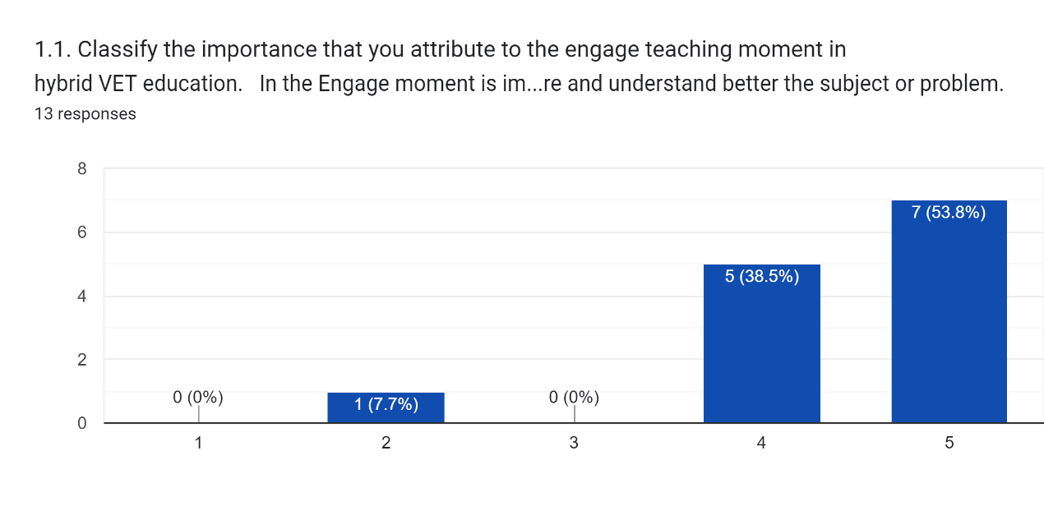

**Greece:**

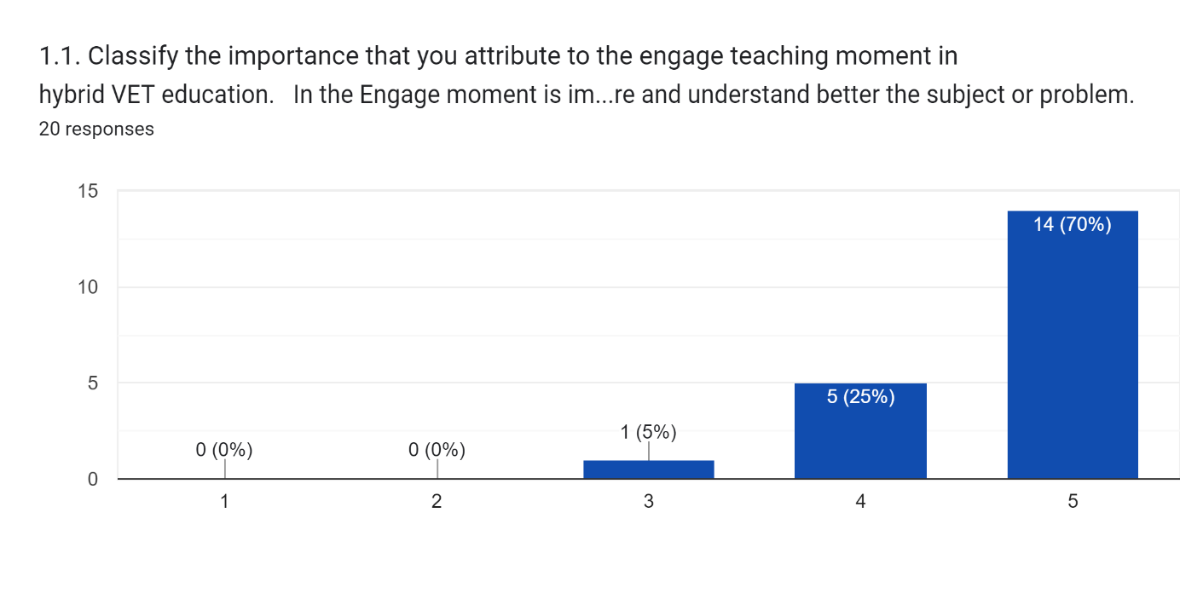

**Poland:**

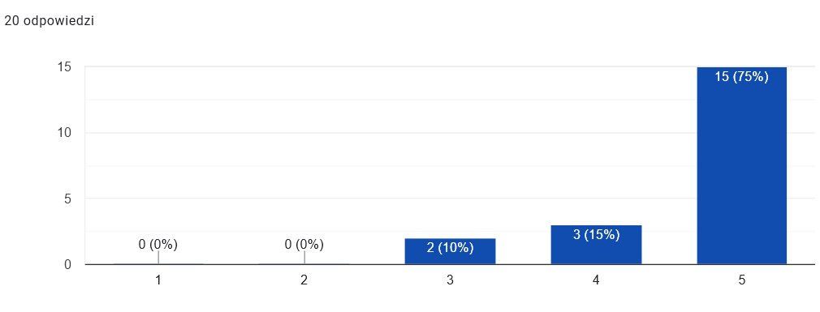

**Portugal:**

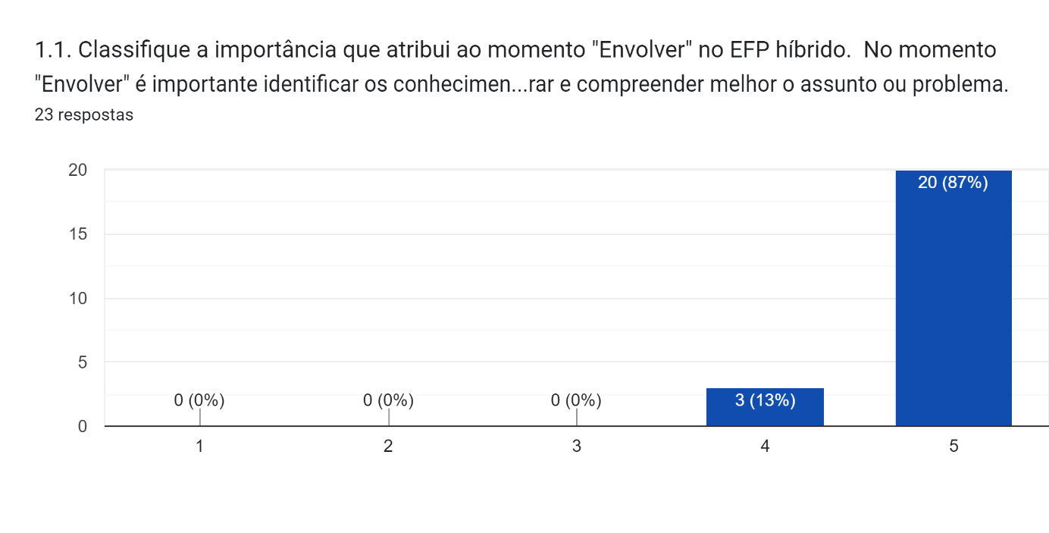

**Turkey:**

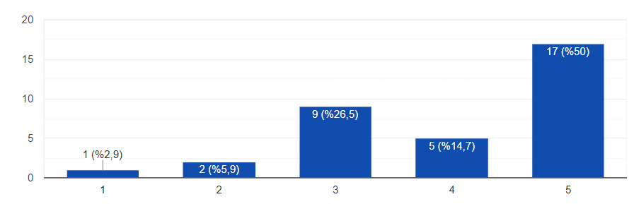

### Explain

The next graphics present the importance attributed to the “Explain” moment by the participants (total and by country).

**Total:**

**Cyprus:**

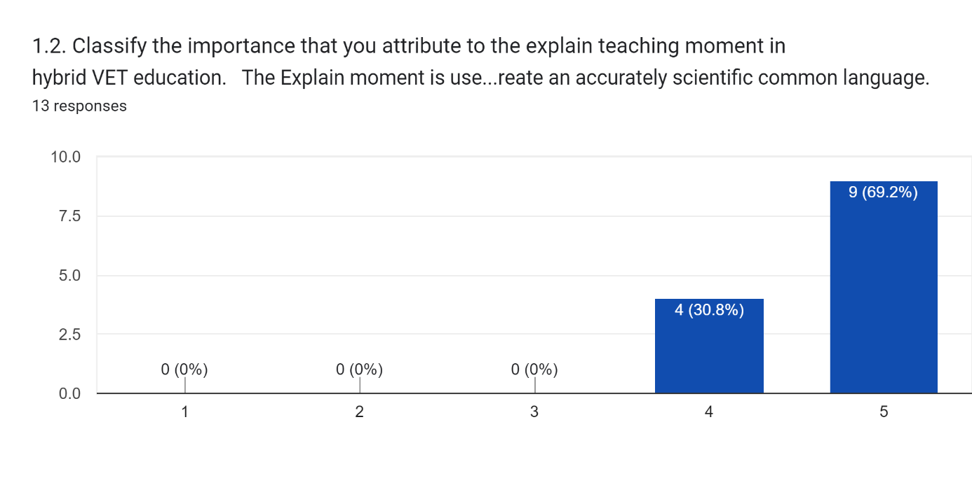

**Greece:**

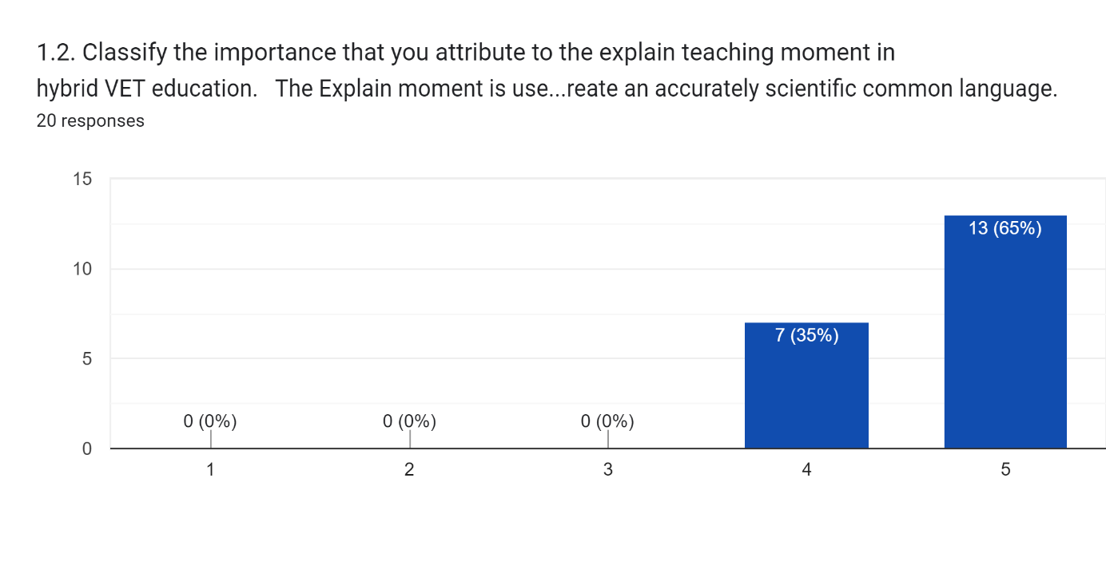

**Poland:**

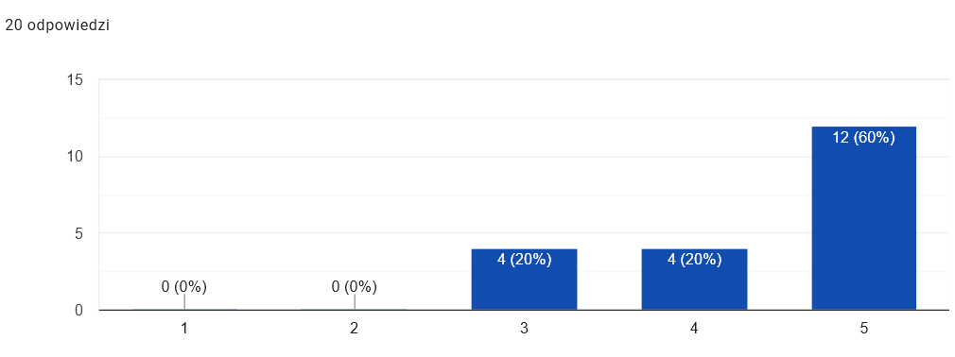

**Portugal:**

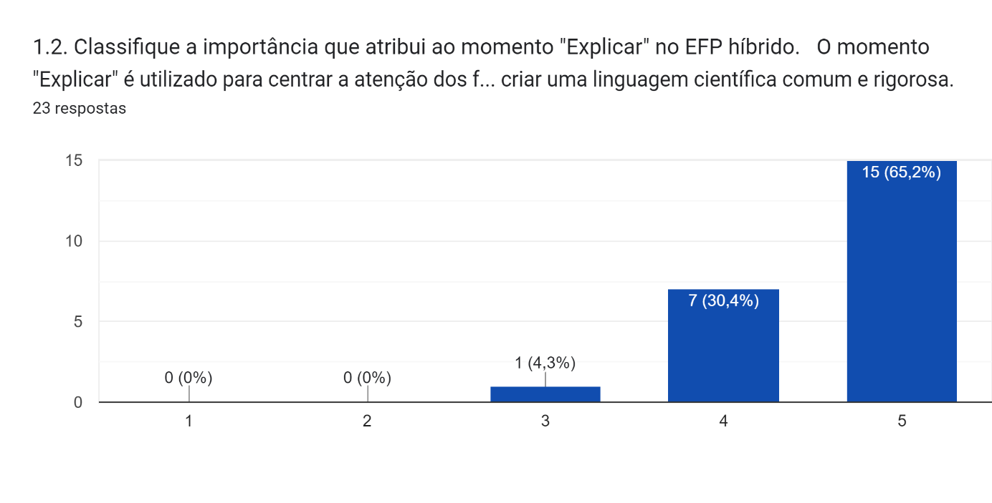 **Turkey:**

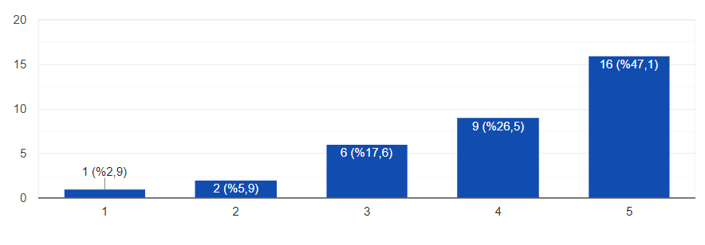

### Explore

The next graphics present the importance attributed to the “Explore” moment by the participants (total and by country).

**Total:**

**Cyprus:**

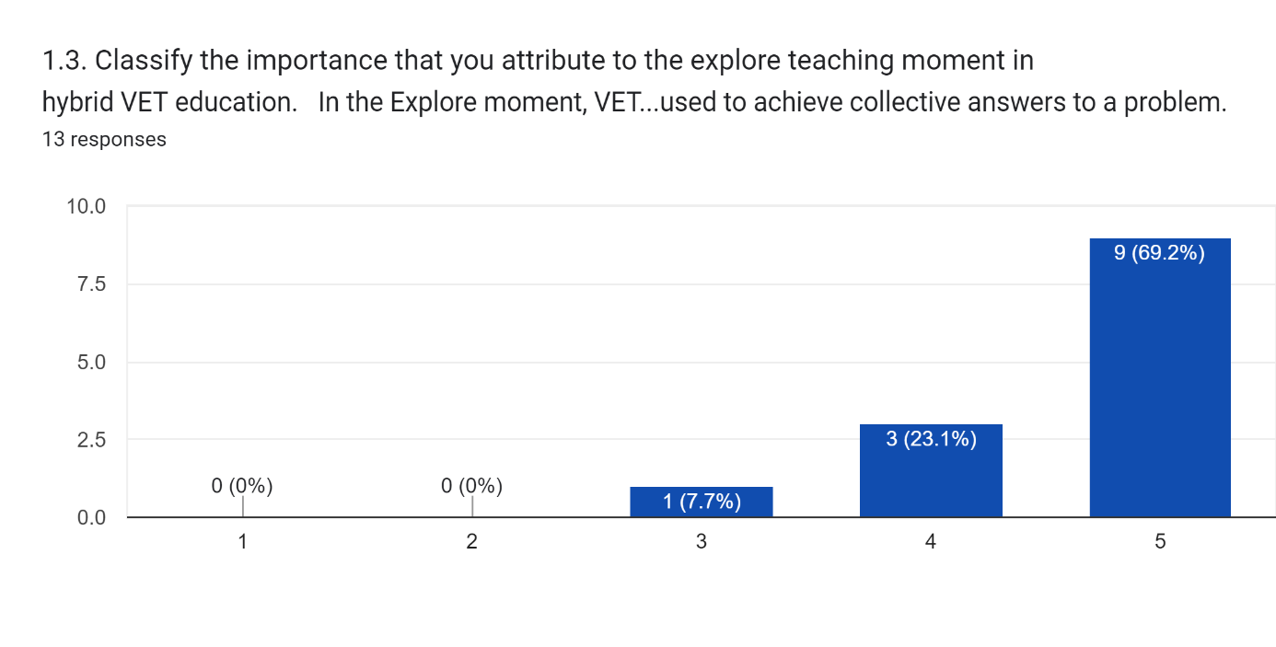

**Greece:**

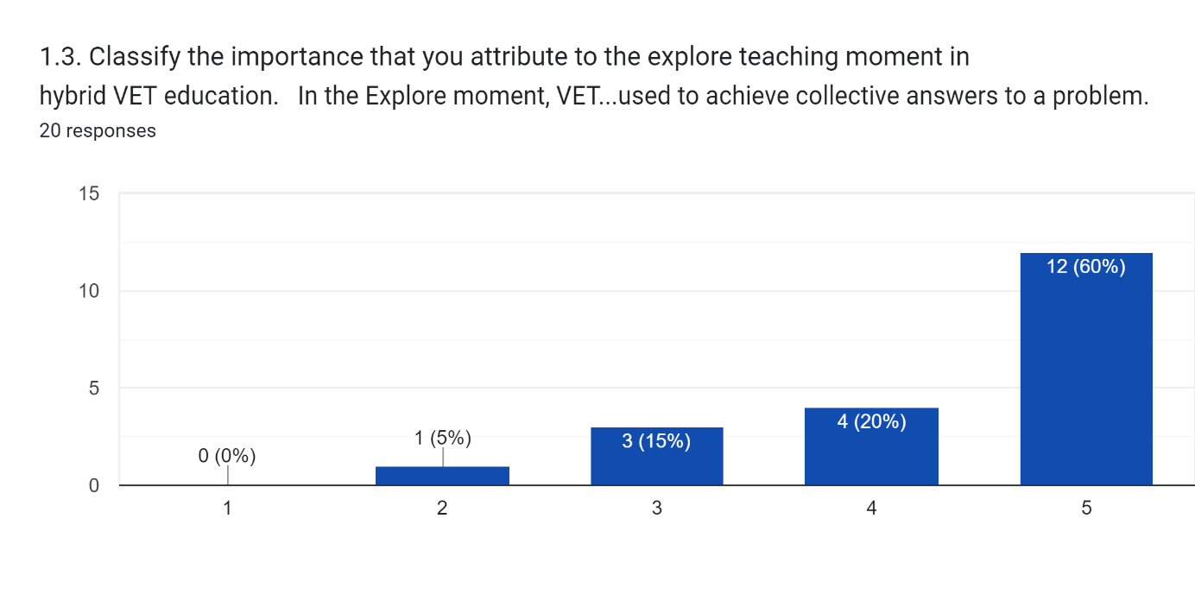

**Poland:**

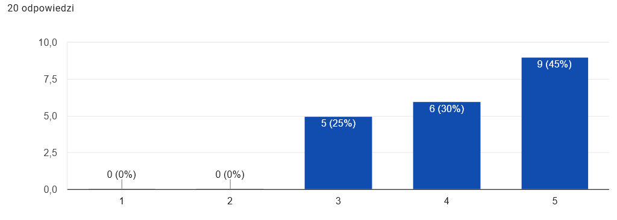**Portugal:**

**Turkey:**

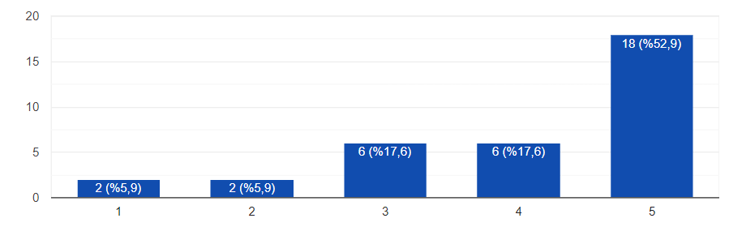

Figure 1. Importance attributed to the “Explore” moment by the participants.

### Elaborate

The next graphics present the importance attributed to the “Elaborate” moment by the participants (total and by country).

**Total:**

**Cyprus:**



**Greece:**

**Poland:**

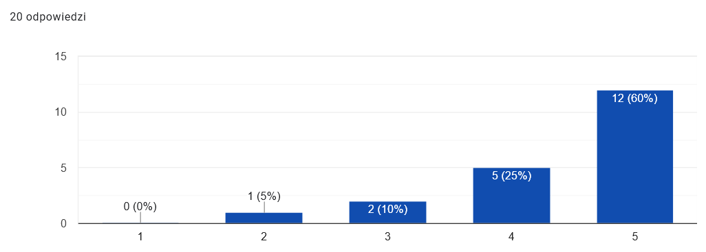

**Portugal:**

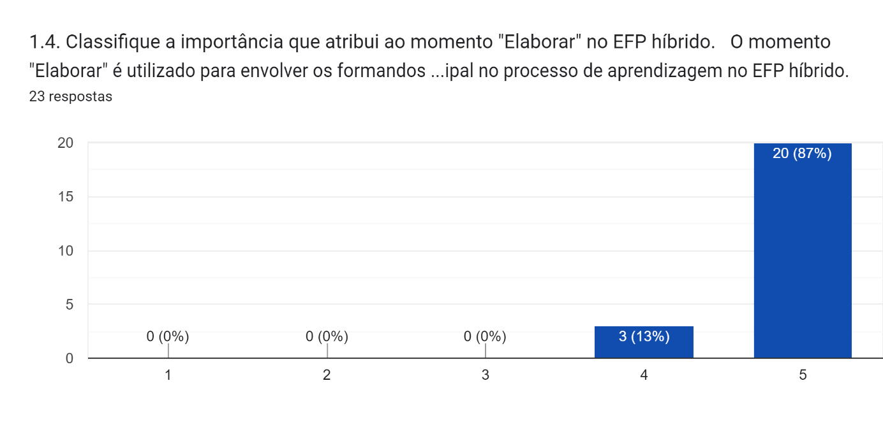

**Turkey:**

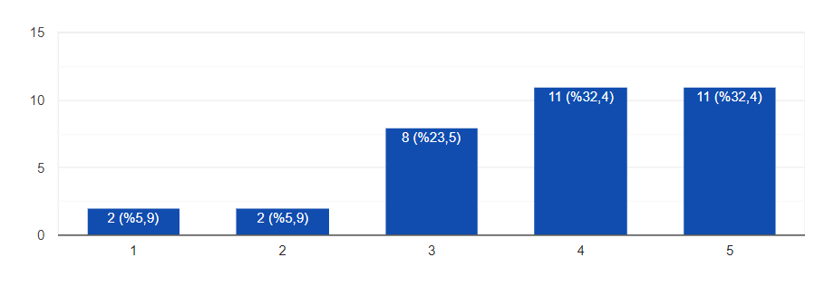

### Exchange

The next graphics present the importance attributed to the “Exchange” moment by the participants (total and by country).

**Total:**

**Cyprus:**

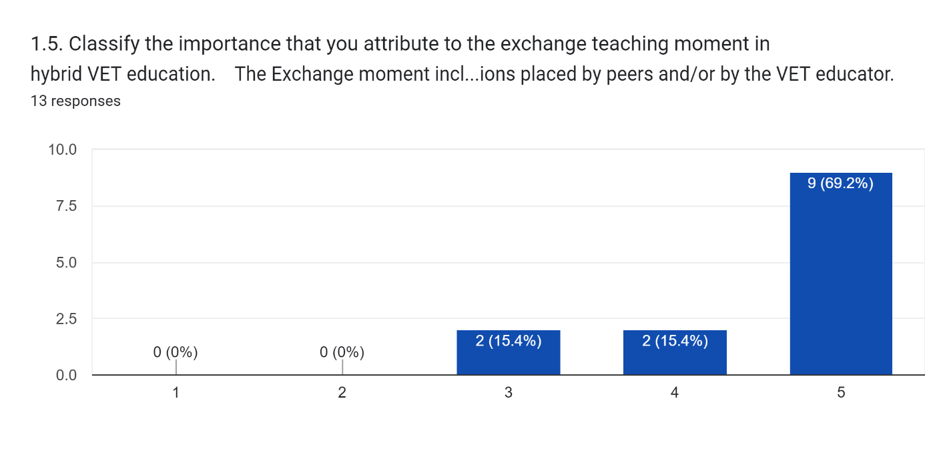

**Greece:**

**Poland:**

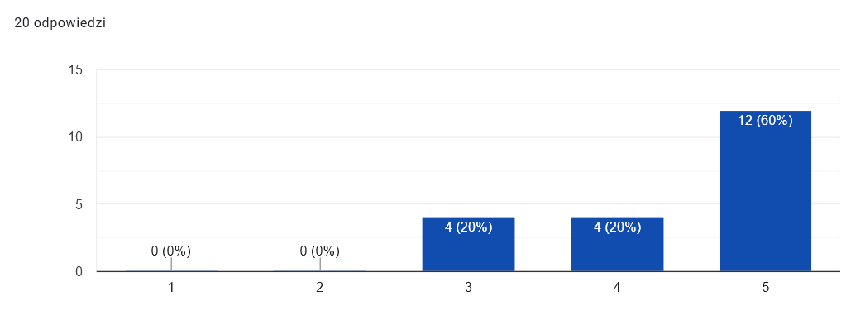 **Portugal:**

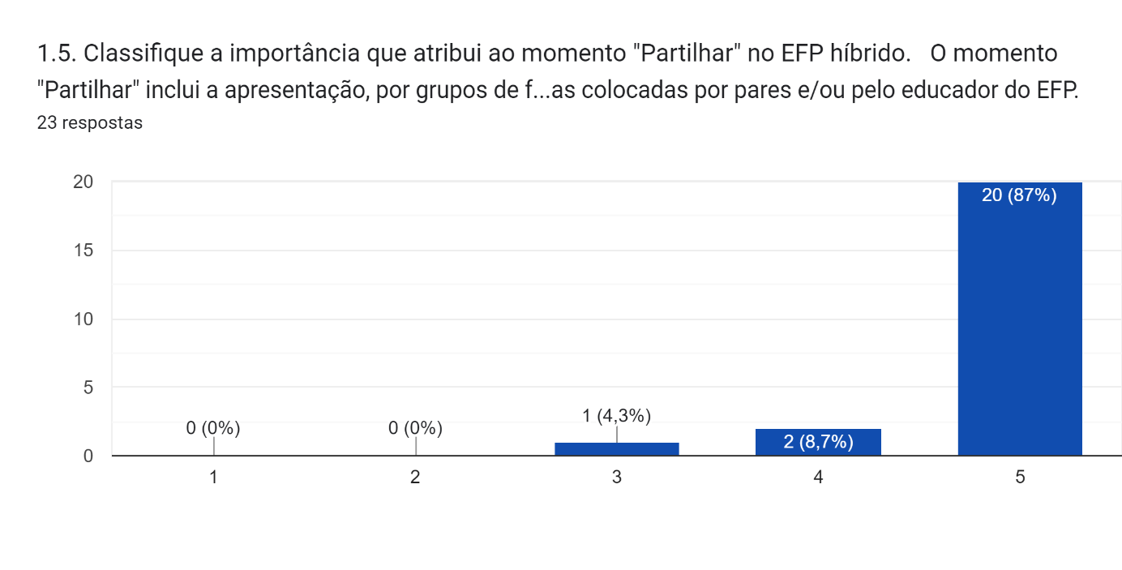

**Turkey:**

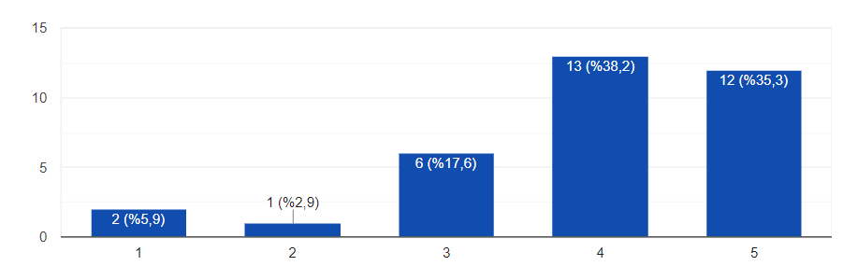

Figure 2. Importance attributed to the “Exchange” moment by the participants.

### Evaluate

The next graphics present the importance attributed to the “Evaluate” moment by the participants (total and by country).

**Total:**

**Cyprus:**

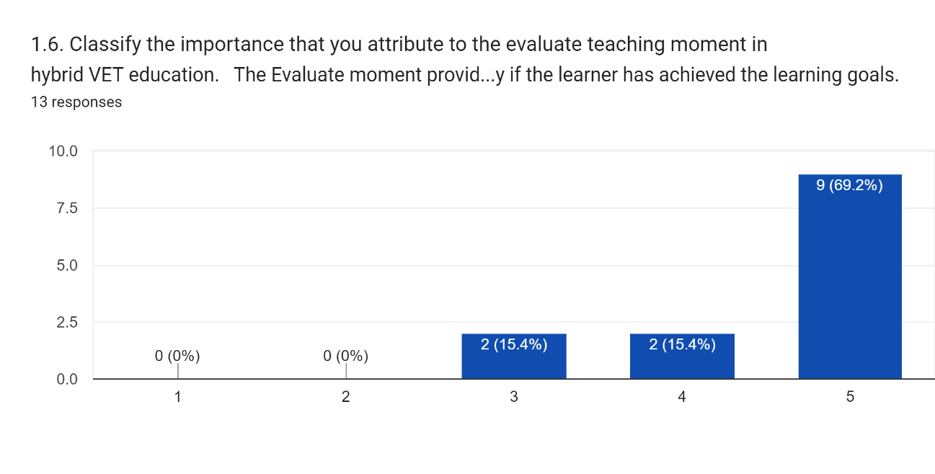

**Greece:**

**Poland:**

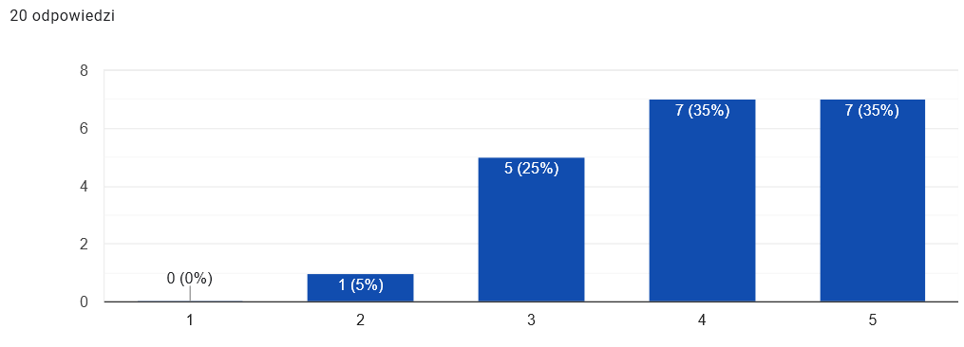

**Portugal:**

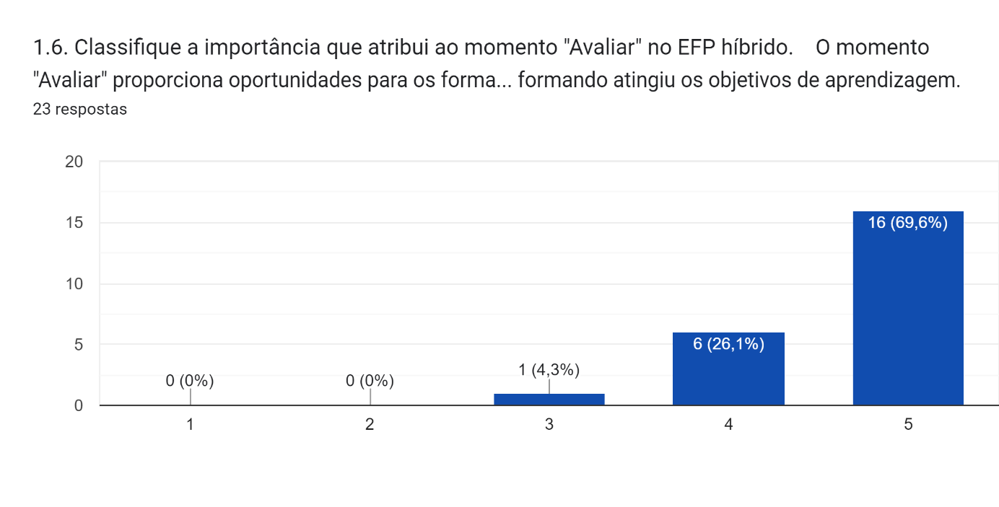

**Turkey:**

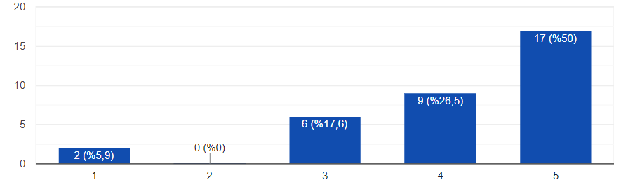

### Empowerment

The next graphics present the importance attributed to the “Empowerment” moment by the participants (total and by country).

**Total:**

**Cyprus:**

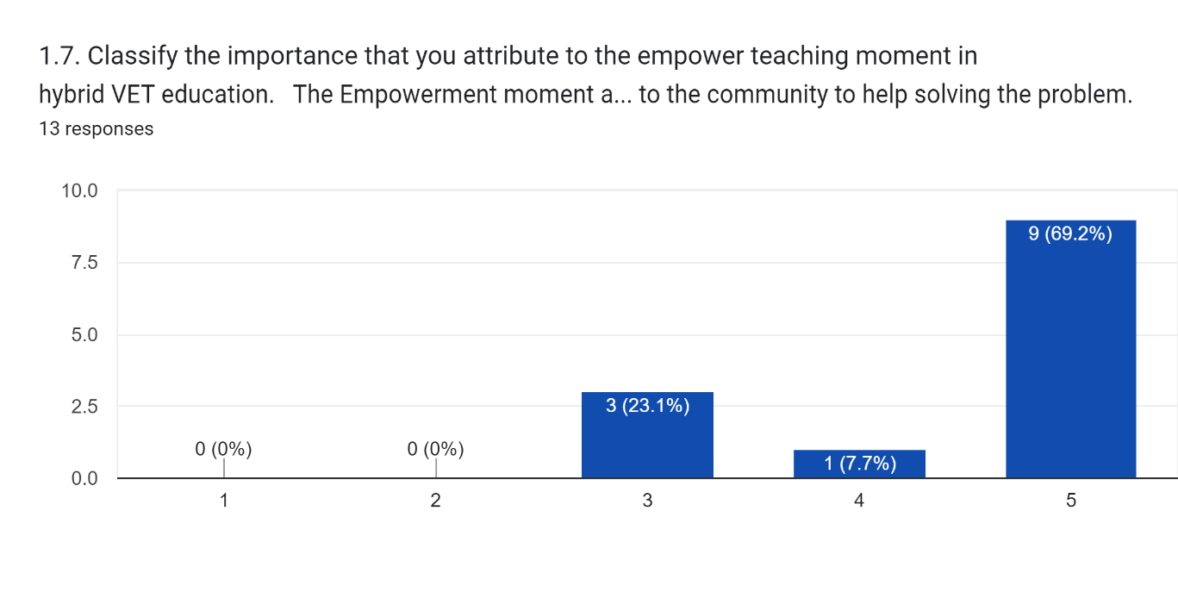

**Greece:**

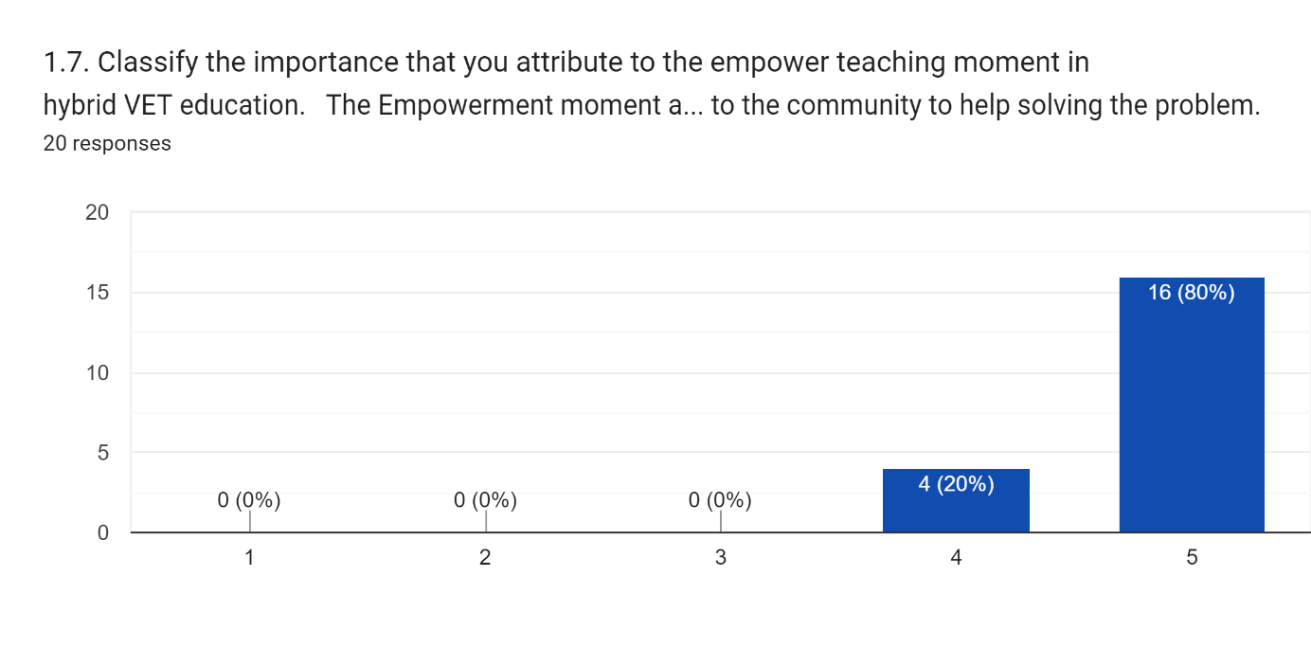

**Poland:**

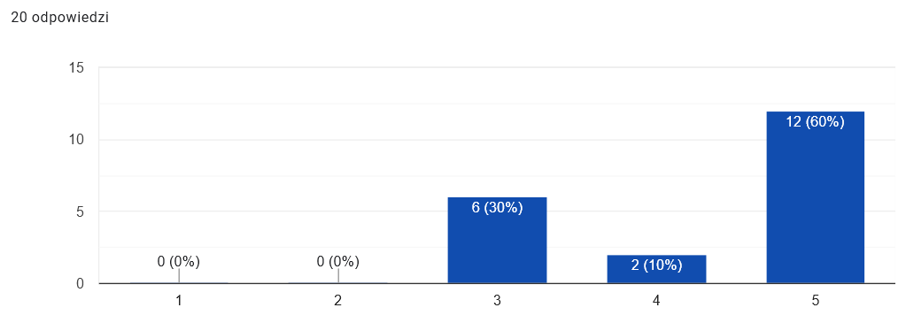

**Portugal:**

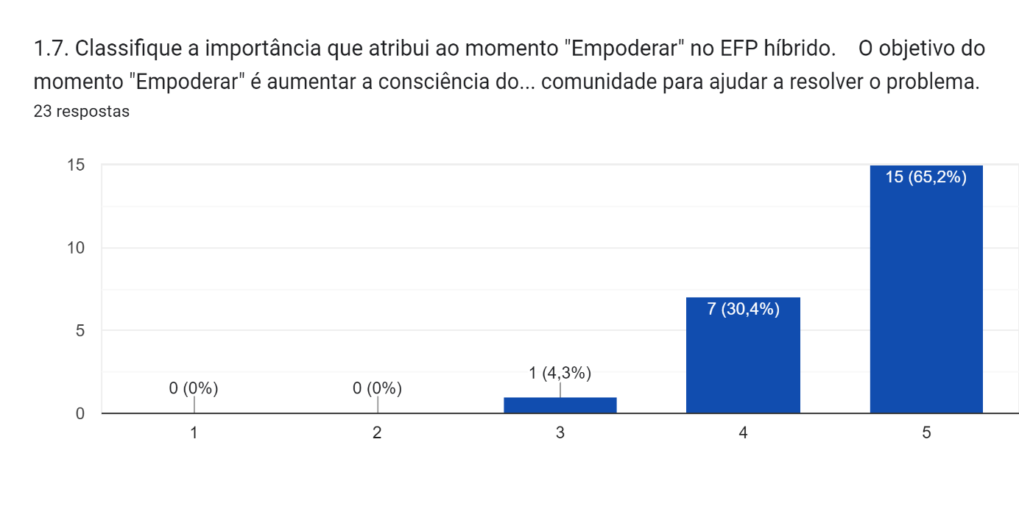 **Turkey:**

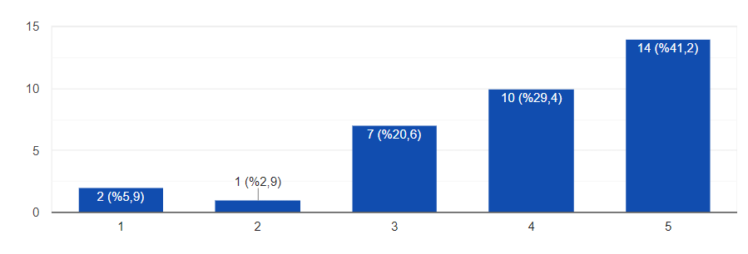

## Facility to understanding of the hybrid model

Figure 8 presents the answers of the participants when asked if the VET hybrid educational model is easy to understand.

**Greece:**

**Portugal:**

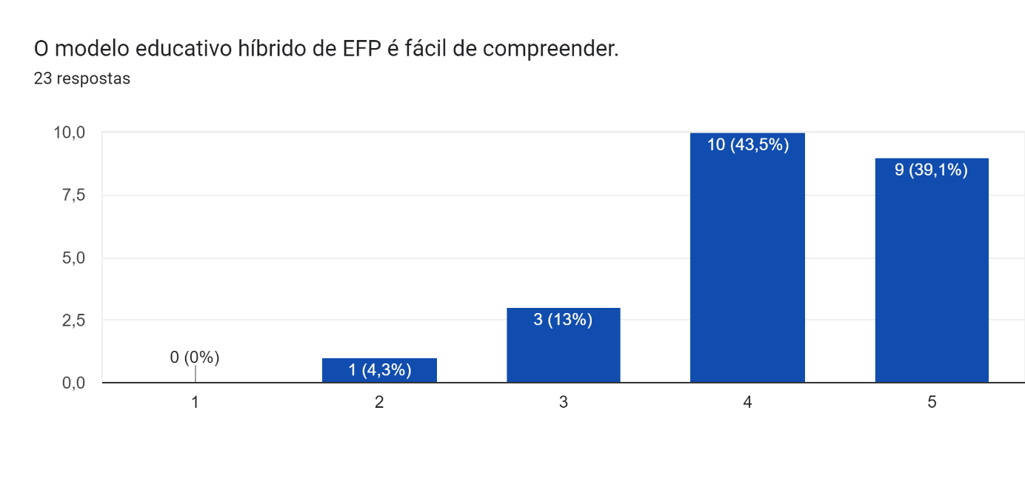

**Turkey:**

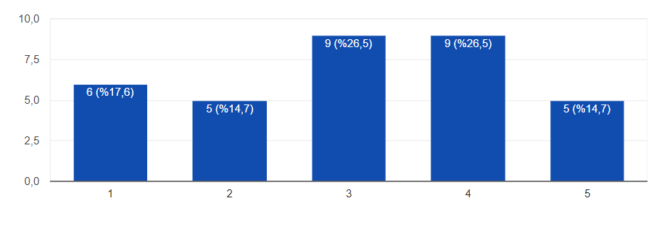

Figure 3. Results of the answers of the participants when asked if the VET hybrid educational model is easy to understand.

## Main strengths of the model presented by the participants

### Comprehensive model

* How the meanings are connected. (Gr)
* Good and long analysis of the model. (Gr)
* Flexibility on the process, coverage of existing needs. (Gr)
* Interesting and modern, generic so it includes a lot of different cases. (Gr)
* Virtual world needs almost all the above. (Gr)
* That is covers all the aspects of effective training. (Cy)
* It covers all steps that a proper training session should cover. (Cy)
* Its components. (Cy)
* The varieties of knowledge. (Cy)
* Easy to understand. The society is not ready yet. The pandemic showed at least to me that the human interaction F2F is more important than distance learning. (Cy)
* All the moments well connected for the final result. (Gr)

### Clear, simple and easy to understand model

* Concrete definition and easy to understand model. (Gr)
* The moments are very well described, the definition easy to understand and transfer to practice. (Gr)
* Helpful, flexible, as generic as possible, concrete, analytical. (Gr)
* Easy to understand, flexible to implement. (Gr)
* Easy to understand, measurable. (Pl)
* Clear and simple. (Pl)

### Development of 21st century skills and soft skills.

* Multifaceted model allows to engage the learner, increase his motivation, allows to form various pro-social skills, implement modern technologies in educational processes, raise the level of education. (Pl)
* Forcing the student to learn independently. (Pl)
* Student working remotely does not get distracted, if some students have a problem with discipline, student works in a place they like. (Pl)
* To give students confidence and tools for problem solving. To motivate for skills development. (Pt)
* The development of hybrid communicational skills. (Pt)
* To enhance the autonomy of students, future citizens of the world. (Pt)
* Flexibility. (Tk)
* An innovative and creative model. (Tk)
* Continuous being open to development and learning, supporting creative productivity, guiding exploration. (Tk)
* A model that increases the student's educational motivation in every environment, ensures that the student is not dependent on the school. (Tk)

### Emphasis on ICT

* Easiness of implementing new learning experiences via the ICT world. (Gr)
* Educational technologies to help achieve learning goals. (Pl)
* Using technology instantly and efficiently. (Tk)
* Flexibility, Accepting the evolution in technology. (Gr)

### Presents a global pedagogical approach to hybrid education

* The empowerment method and all the interconnections of the moments above. (Gr)
* Enables participation and ability to record and view again. (Cy)
* Emphasises the importance of informing individuals prior their engagement in hybrid education. (Cy)
* That helps the VET teachers to form their learning process. (Cy)
* Individual learning, solving to problem of distance learning during isolation conditions. (Cy)
* In practical vocational education, the biggest advantage of such a model would be the ability to record such a lesson and then discuss it. Discussing the specific mistakes, a student made would allow that student to analyse (like a replay in a match) their actions. (Pl)
* Provides the opportunity to use a very wide range of teaching methods to increase the effectiveness of learning. (Pl)
* To motivate the trainees, explain the concepts but promote independent study and research and promote the sharing of learning. (Pt)
* To share and explore. (Pt)
* Comprehensiveness. (Pt)
* To make known the various stages involved in the hybrid educational model. (Pt)
* The 7 E's! Active learning and in action, involving the student in his/her own formative process. (Pt)
* The different stages of the process. (Pt)
* Apparently not presenting great difficulty in implementation. (Pt)

### Inclusiveness

* The way it combines all the factors of successful teaching while also adapting to the needs of the students and the times. (Cy)
* Equal opportunities for the participants that cannot attend the training with physical presence, at the same time with the rest of the class. (Cy)
* Involving all participants in the process. (Pl)
* Accessibility for students unable to study at school. (Pl)
* Ability to engage all students. (Pl)
* Ability to work simultaneously with students stationary and remotely. (Pl)
* The involvement of all participants. (Pt)
* Awareness that for learning to take place the active role of the learner is fundamental. (Pt)
* Comfort. v
* Involving and sharing. (Pt)
* To be inclusive and value the close relationship with companies. (Pt)
* Inclusion is an added value of this hybrid model, as in other distance learning methodologies. (Pt)
* Integration of the dimension of inclusion and business. (Pt)
* Inclusion and the active learning model. (Pt)
* It is an inclusive model. (Pt)
* Independently of each one's impediment, everyone can participate. (Pt)
* Accessibility and equality. (Tk)

### Others

* Fewer people in the classroom so need smaller rooms. (Pl)
* Optimization. (Pl)
* If the student wants to learn there is no interference from classmates. (Cy)
* Continuing education in extraordinary situations. (Tk)
* Students may not complain about the excess of lesson hours. (Tk)
* Education is not disrupted. (Tk)
* Analytical and generic so trendy in tech development with time. (Gr)
* Very good analysis. (Gr)
* Neat analysis. (Gr)
* Analytical. (Gr)
* The interlinks. (Gr)
* Good analysis and good description on the needed connections. (Gr)
* Strong and well put, good analysis (even though long), extremely helpful. (Gr)

## Needed changes to the model, presented by the participants

### No changes or suggestions / I agree with the model

* None. (Gr)
* Seems fair enough. (Gr)
* It is totally fine. (Gr)
* None. (Gr)
* No need. (Gr)
* None. (Cy)
* I think it's good as it is. (Cy)
* It's fine. (Cy)
* For the moment, no suggestions. (Pt)
* I agree. (Pt)
* Nothing to add. (Pt)
* No change. (Pt)
* Nothing to add. (Pt)
* None. I liked it a lot. (Pt)
* Now, none. (Pt)
* Would not change anything. (Pt)
* No suggestion. (Pt)
* For the moment, none. (Pt)

### Changes or suggestions

* Take into account the Greek reality of technical schools who luck infrastructure and budget. (Gr)
* Taking into consideration that after COVID, the hybrid became a must, students are now ready for this. They just need to receive some kind of support in terms of an easy to use a manual step by step with further advice of being empowered. (Gr)
* The Greek environment needs some good connections with companies, need advice on how to deal with this. (Gr)
* As technology evolves be open to modifications. (Gr)
* More practical and pragmatic approach on everyday implementation to GREEK IEKs. (Gr)
* More examples. (Gr)
* No changes needed but a manual with examples would help more. (Gr)
* More practical approach. (Gr)
* Practical explanation on the theory. (Gr)
* Thorough elaboration on empowerment and evaluation. (Gr)
* Amend it with good practices and case studies. F&As. (Gr)
* Analyse the methodological elements with examples and how to connect them. (Gr)
* Leave it flexible and according to different styles per school. (Gr)
* Amend examples and case studies to take inspiration on how to implement it in our case. (Gr)
* We need better PC. (Cy)
* Maybe some examples of activities and learning material can be added. (Cy)
* When we reach Hologram's technology at its full potential maybe distance learning will work. (Always talking about Cyprus). (Cy)
* Interesting visual can help. (Cy)
* Very year has to be a small upgrade is made based on the evolution of needs. (Cy)
* Where it says Companies, should be placed "Organizations" to include organizations (including social economy and educational). (Pt)
* Some kind of activity monitoring on electronic devices. (Pt)
* Allow the data to be constantly updated. (Pt)
* Consider the importance of the existence of structures for the production and realization of specific contents, for this teaching model and of teams of specialists in different areas and with different profiles, for its implementation. (Pt)
* Explanation of the advantages in relation to other distance learning models. (Pt)
* Introduction of the reference to digital resources, and besides inclusion, also integrate collaboration. (Pt)
* The participation of companies could be an added value. (Pt)
* Implementation capacities of institutions should be developed. (Tk)
* Promote and disseminate more. (Tk)
* Providing continuous training both face-to-face and online. (Tk)
* Hardware needs to be strengthened. (Tk)
* Students should be encouraged. (Tk)
* Teachers should be given more freedom, they should not be overwhelmed with procedures and bureaucracy, they should be encouraged to improve themselves and be more beneficial to their students instead of dealing with drudgery.
* Increasing the general budget allocated to education and hybrid model investments within this budget, keeping the model on the agenda and emphasizing its importance and necessity in appropriate environments. (Tk)
* All students and teachers can be given the opportunity to access these trainings.
* More emphasis should be placed on the application. (Tk)
* Effective use of information tools. (Tk)
* Content planning should be appropriate.
* Conducting exams in the form of e-exams should be expanded. (Tk)

## Additional comments about the VET hybrid educational model

At the end of the teachers' survey, they were allowed to enter other comments on the presented hybrid teaching model in vocational education and training. In most cases, they entered nothing or added "no comments." However, some participants presented additional comments:

* In this day and age, and with the current attitude of students toward learning, hybrid teaching is difficult to implement. (Pl)
* The presented hybrid teaching model is complete, thought out in detail. (Pl)
* I like the presented model. (Pl)
* The model is based - from what I understood - on close cooperation with companies - but in reality - companies are rarely directly involved in education to the extent proposed. (Pl)
* A big plus is the even and alternating implementation of remote and on-site classes. (Pl)
* I think this model will not quite work for all professions.
* I believe that hybrid teaching is disadvantageous for students and for the teacher. (Pl)
* Teaching remotely and stationary at the same time is very difficult to do in most cases and makes it difficult for both remote and stationary students. Remote teaching should be used for the whole department at the same time for theoretical improvement, while classes requiring practical training should be held stationary. (Pl)
* I am a teacher of practical subjects, where one learns by doing a specific task with their own hands. I think this model will not quite work for all professions. (Pl)
* Dynamic and challenging model. (Pt)
* Congratulations to the work team for the initiative of creating a hybrid model for vocational training, which seems fundamental to the evolution of the teaching learning process. I hope it can be quickly implemented. (Pt)
* Nothing to remark. (Pt)
* Congratulations on the work that is being done. (Pt)
* We must be very careful not to "fool" anyone with diplomas when the essential skills of work, critical thinking, collaboration and concentration have been poorly developed. (Pt)
* Excellent work, much success. (Pt)
* Further references will certainly be missing. Entities... (Pt)
* I think this is the ideal learning model for today's young people. It is motivating and self-involving. It is research/action! It is being involved in a project! (Pt)
* In my opinion, it needs more refined conceptualization work. (Pt)
* It is expected that the participation rate will increase, and the drop-out rate will decrease. (Pt)
* The model is only viable if it is effectively implemented and practical. (Pt)

# Future participation in a focus group about the VET hybrid educational model

Approximately half of the participants said that they are available to participate in future focus groups, and the other half are unavailable to participate in focus groups (Figure 4).

**Portugal:**

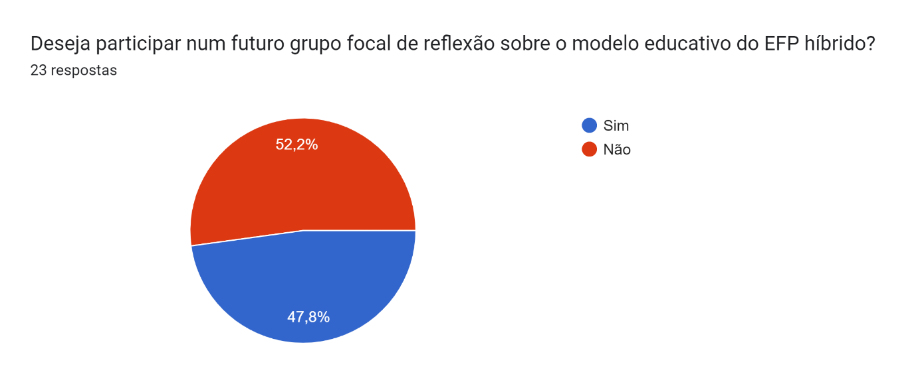

**Turkey:**

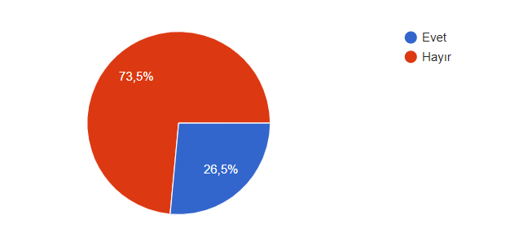

Figure 4. Results of the answers of the participants when asked if they want to participate in a future focus group.

# Focus groups

## Guidelines for the focus groups

The focus group should consist of 3 to 8 VET teachers.

Dates of application of the focus group: until yyy 2023.

Date for submission of the national report: until yyy, 2023.

## Questions

Please add in the following list other possible participants of the focus groups about the hVET project hybrid educational model.

|  |
| --- |
| **Participants** |
| * VET teachers * VET tutors * VET students * Collaborators of companies * VET school management staff * Experts in online teaching and/or hybrid models * Other school experts (such as psychologist, career counsellors, etc.) |

Please add in the following table additional questions to inquiry the participants of the focus groups about the hybrid VET educational model.

|  |
| --- |
| **Questions** |
| The hybrid VET educational model is adequate for:   * facilitate VET’ students learning? * keep students motivated? * reduce possible school dropouts? * mitigate classroom fatigue of teachers and students? * teach vocational skills remotely? * promote an inclusive learning environment? * the usage of digital technologies?   About hybrid education:   * Based on your experience, what are the three main factors that might be affecting hybrid teaching and how can we overcome these? Please provide specific examples and solutions, if you’ve encountered any, through your experience. * Are there any digital educational tools that you have used that have proved to be efficient in hybrid teaching? If yes, in what ways? Please explain by giving specific examples (e.g.: helped in increasing and maintaining students’ participation, audiovisual and interactive material, etc.) * What was the greatest challenge you encountered when delivering a hands-on subject in hybrid mode?     About the VET educators:   * Based on your experience, what skills do you think VET teachers/educators need to develop further in order to improve the delivery of their lessons in hybrid teaching?   About the VET learners:   * What qualities of a student in hybrid education should be diagnosed by the psychometric test we want to build as part of the project? (Pl)   About the hVET course:   * Do you wish to receive a certificate of the course? What kind of certificate?   How do you envisage the Hybrid Education Model been implemented in your own classroom?  (open)  What would be the most frequent problems?   * Technological problems * Lack of collaboration among the teacher and the student * Lack of understanding the sequence and the steps of the proposed model * Other (small description)   About the game:   * Q1: Do you think a male / female figure in a supporting game would fit or would you prefer a neutral figure? * Q2: Describe one offline activity that your class would enjoy through a supportive game? * Q3: Would your class enjoy an online rivalry with a class from another country or just a class from another universe (internationality without borders)? |